MUNICIPALITY OF TUZI
Project: ADRIA_Alliance, ADRIAtic cross-border ALLIANCE for the promotion of energy efficiency and climate change adaptation, IPA II CBC ITALIA – ALBANIA -MONTENEGRO, No. 397

SUSTAINABLE ENERGY AND CLIMATE ACTION PLAN
(SECAP)

Author:
MSc Nebojsa Jablan, dipl. el. eng

August, 2021

INDEX

TABLE OVERVIEW 4
PICTURES OVERVIEW 5
INTRODUCTION 6
1.1 General information about Municipalty of Tuzi 6
1.1.1 Geographical position 6
1.1.2 Soil 6
1.1.3 Water 6
1.1.4 Forests 7
1.1.5 Mineral resources 7
1.2 Covenant of Mayors for energy and climate 8
1.3 Municipality of Tuzi and Covenant of Mayors 8
2. METODOLOGY 10
3. ENERGY CONSUMPTION AND CO2 EMISSIONS IN THE BASE YEAR 12
3.1 Analysis of energy consumption in the building sector 12
3.1.1 Municipality-owned buildings 12
3.1.2 Commercial and service sector buildings 13
3.1.3 Residential buildings 14
3.1.4 Analysis of total consumption in the building sector 15
3.2 Analysis of energy consumption in the public lighting sector 15
3.3 Analysis of energy consumption in the transport sector 16
3.3.1 Municipality vehicles 16
3.3.2 Public transport 17
3.3.3 Town road transport 17
3.4 Analysis of the total energy consumption of the Municipality of Tuzi 21
4. EMISSION REFERENCE INVENTORY 22
4.1 Building sector 22
4.2 Public lighting sector 23
4.3 Transport sector 23
4.4 Total emissions in the reference year by sectors 24
5. RISK AND VULNERABILITY ASSESSMENT TO CLIMATE CHANGE 25
5.1 The climate of the Municipality of Tuzi 25
5.1.1 Observed changes in temperature, precipitation and extreme events 27
1.1 IPCC definition - variability and climate change 27
5.1.2 Expected temperatures, precipitation and extreme events 30
5.2 Risk assessment and vulnerability to climate change 32
5.2.1 Observed extreme events - hazards 32
5.2.2 Vulnerability of local government or region 38
6. CLIMATE CHANGE MITIGATION MEASURES 47
7. MEASURES TO ADAPT TO CLIMATE CHANGE 58
8. ASSESSMENT OF THE EFFECTS OF CLIMATE CHANGE MITIGATION MEASURES 68
8.1 Building sector 68
8.2 Public lighting 68
8.3 Transport 69
8.4 Overall overview 69
9. IMPLEMENTATION OF THE ACTION PLAN 72
9.1 Implementation organization 72
9.2 Implementation monitoring and reporting 72
9.2.1 Coordination 72
9.2.2 Reporting 72
9.2.3 Support 73
9.3 Structural adjustment 73
10. PROVIDING RESOURCES FOR IMPLEMENTATION OF THE ACTION PLAN 74
10.1 Human Resources 74
10.2 Sources of finansing 74
10.2.1 National sources of financing 74
10.2.2 European sources of finansing 74
10.2.3 European Structural and Investment Funds 74
CONCLUSION 76
LITERATURE 77

TABLE OVERVIEW
Table 3.1 Structure of facilities by purpose in the Municipality of Tuzi 12
Table 3.2 Overview of basic characteristics and energy consumption of public buildings on the territory of the Municipality of Tuzi in 2019 12
Table 3.3 Energy consumption of public buildings in 2019 13
Table 3.4 Total annual energy consumption in the building sector 15
Table 3.5 Fleet structure by type of vehicle for 2020 18
Table 3.6 Overview of total fuel consumption in the Municipality of Tuzi 19
Table 3.7 Energy consumption in the transport sector 20
Table 3.8 Total energy consumption by sectors in the reference year 21
Table 4.1 Emission factors 22
Table 4.2 Total CO2 emissions by building subsectors (tCO2) 22
Table 4.3 Total CO2 emissions by transport subsectors (tCO2) 23
Table 4.4 Total CO2 emissions by sector 24
Table 5.1 Mean annual air temperature by decades and its changes ∆1 and ∆2 (0C) in relation to the climatological normal 1961-1990 at the main meteorological stations Podgorica and Golubovci 27
Table 5.2 Projected changes in mean seasonal and annual temperatures for Tuzi 31
Table 5.3 Projections of changes in mean seasonal and annual precipitation, number of days with heavy precipitation, number of consecutive dry days and changes in snowfall 31
Table 5.4 Fire damage in 2020 and 2021 34
Table 5.5 Flood damage in 2020 and 2021 35
Table 5.6 Damage from storms 36
Table 5.7 Risks of climate hazards of particular importance to Tuzi 37
Table 5.8 Socio-economic vulnerability, physical and environmental vulnerability of the Municipality of Tuzi 38
Table 5.9 Demographic structure of the population 42
Table 5.10 Expected impacts of climate change on certain sectors in the Municipality of Tuzi 43
Table 7.1 Summary of climate change adaptation measures 66
Table 8.1 Energy consumption in the building sector in 2030 [MWh] 68
Table 8.2 CO2 emissions in the building sector in 2030 [tCO2] 68
Table 8.3 Energy consumption in the public lighting sector in 2030 [MWh] 69
Table 8.4 CO2 emissions in the public lighting sector in 2030 [tCO2] 69
Table 8.5 Energy consumption in the transport sector in 2030 [MWh] 69
Table 8.6 CO2 emissions in the transport sector in 2030 [tCO2] 69
Table 8.7 Total energy consumption by sectors in 2030 [MWh] 70
Table 8.8 Total CO2 emissions by sector in 2030 [tCO2] 70

Figure overview
Figure3.1 Structure of the total area of ​​buildings according to purpose 12
Figure3.2 Structure of energy consumption in public buildings of the Municipality of Tuzi in 2019 13
Figure3.3 Structure of energy consumption in the residential sector in 2019 14
Figure3.4 Structure of energy consumption in the residential sector 14
Figure3.5 Structure of energy consumption by subsectors of buildings 15
Figure3.6 Structure of light bulbs used in public lighting according to the type of light source 16
Figure3.7 Freight transport on the route Podgorica-Tuzi [tons] 17
Figure3.8 Trend of change in the total number of registered vehicles and their share by fuels of interest 18
Figure3.9 Vehicle structure by type of fuel for Montenegro in 2020 19
Figure3.10 Fleet structure according to the purpose of the vehicle 19
Figure3.11 Structure of motor fuels according to energy value 20
Figure3.12 Share of subsectors in total energy consumption of transport sector 20
Figure3.13 Structure of total energy consumption by subsectors in the reference year 21
Figure4.1 Structure of CO2 emissions by subsectors of buildings 23
Figure4.2 Structure of CO2 emissions by transport subsectors 23
Figure4.3 Structure of CO2 emissions by sectors of interest for the reference year 24
Figure5.1 Annual course of mean monthly maximum and minimum temperatures in Golubovci for the period 1981-2010. 25
Figure5.2 Mid annual (graph above) and mid monthly wind speeds (graph below) according to data at the meteorological station in Golubovci 26
Figure5.3 Deviations of the average annual temperature in Podgorica in relation to the climatological normal 1961-1990 28
Figure5.4 Percentage of hot days Tx> = 90th percentile and warm nights Tn> = 90th percentile in Podgorica in relation to the climatological normal 1961-1990. 28
Figure5.5 Spatial distribution of average annual precipitation (left) for the period 1981-1990. and its deviations (right) in relation to the climatological norm 1961-1990 (Source: Second National Report of Montenegro according to UNFCCC) 29
Figure5.6 Length of the longest heat wave duration (left, HWD-EHF index) in Podgorica 30
Figure5.7 Annual precipitation intensity (mm / day) in Podgorica 30
Figure5.8 Vulnerable households at the extreme water level of Skadar Lake in the period from December 2010 to January 2011 (GIZ project Adaptation to Climate Change in the Western Balkans) 34
Figure5.9 Flooded areas due to the overflow of the river Rujela from 30.11. to 01.12.2010. (GIZ project "Adaptation to climate change in the Western Balkans) 35
Figure5.10 Population aged 15 and over by economic activity 43
Figure8.1 Overview of the effects of measures 70
Figure8.2 Comparison of scenarios with measures (MIT) versus baseline (BAU) with reference year and target 71

INTRODUCTION

General information about Municipality of Tuzi

Geographical position
The municipality of Tuzi is located in the southeast of Montenegro and covers an area of ​​246.8 km2, which is 1.79% of the total area of ​​Montenegro, which is 13,812 km2. According to the Law on Territorial Organization, the Municipality of Tuzi, based in Tuzi, includes Tuzi as a settlement of urban character and settlements: Arza, Barlaj, Vuksanlekići, Gornja Selišta, Gornji Milješ, Gurec, Zatrijebač, Poprat, Rudine, Budza, Benkaj, Delaj, Mužečka, Nikmaraš, Stjepovo, Koće, Dinoša, Donja Selišta, Donji Milješ, Drume, Krševo, Lovke, Passhkala, Pikalja, Prifta, Pothum, Skorać, Spinja, Traboin, Nabom, Helmica, Šipčanik, Vranj, Vladne, Drešaj, Dušiće, Koderbudan, Omerbožovići, Sukuruć, Cijevna i Kuće Rakića and other settlements determined by a special decision of the municipality.
Municipality of Tuzi has an excellent geostrategic, geopolitical and economic position: it is about 40 km away from the Adriatic Sea, while the border crossing with the Republic of Albania - Božaj is on its territory only 14 km away from Tuzi. The Municipality of Tuzi is bordered by Skadar Lake on the south side; on the west and north side it borders with the Capital City of Podgorica, and on the east side with the Republic of Albania.

Soil
The pedology of the area of ​​the Municipality of Tuzi has not been sufficiently studied, which requires time, resources, experts and a lot of work. Lands should be given more attention because they have a very significant potential as economic resources of this area. The pedological potential of Tuzi is related to the carbonate stone, this stone forms the basis on which different types of soil were created. Due to this, the types of land have these characteristics to a greater extent. These are karst soils, which are divided into several types based on pedological characteristics. In addition to these soils, alluvial carbonate soils also appear in the Tuzi area, which are of great importance for the development of agriculture in this area. Overview of different lands in the Tuzi area:
- Organo-mineral and peat soils are spread on the coastal part of Skadar Lake. These are mostly wetlands;
- Alluvial - carbonate soils with a deep profile, these are agricultural soils, are of great importance for agricultural production;
- Alluvial - carbonate soils with shallow profile, are important for the development of vegetable growing;
- Sedimented and anthropogenic red soils - Terra rossae, are spread at the foot of hills, depressions. They are of great importance for hilly areas;
- Eroded and stone red soil is very widespread in the area of ​​Tuzi, these are mainly pastures and it is not of great importance for agricultural production, humus red soil; - Brown shallow soils on the fluvioglacial layer, brown very shallow soils on the fluvioglacial layer, brown forest carbonate soils, black carbonate soils; - Black carbonate karst soils are present on small areas - symbolically, usually around the tops of hills, they have no agricultural significance.

Water
The hydrography of the treated area is complex. This is confirmed by the large number of hydrographic objects and the large distribution and their hydrographic characteristic. The hydrography of the municipality of Tuzi is affected by: Skadar Lake (part that belongs to the treated area), Cijevna River, river Rujela as well as some mountain rivers, and several springs such as springs, estavels, lacustral and sublacustral springs, etc. The largest hydrographic facility and the most important for the municipality of Tuzi is Skadar Lake.
Skadar Lake is international and stretches between the Republic of Albania and Montenegro. Skadar Lake covers an area of ​​about 540 km², during the maximum level, and during the minimum level, the surface of the lake decreases to about 369.72 km². The Republic of Albania has about 1/3 of the area. The largest part of the lake should territorially belong to the Municipality of Tuzi. Skadar Lake was declared a National Park in 1983. This lake is the largest lake in the Balkans. On the tectonic aspect, crypto - depression is the largest in Europe, and at the same time it is the largest freshwater pool in the Balkans. A large number of lacustral and sublacustral springs appear on part of the hill and at the bottom, enriching the lake level. In addition to these springs, Skadar Lake is also enriched with water from the Morača River. The river Bojana is an island of Skadar Lake about 41 km long and flows into the Adriatic Sea. The Bojana River forms part of the border between Montenegro and Albania. Skadar Lake is a national park and represents a very important natural resource of Tuzi and Montenegro in general, which is insufficiently used and insufficiently well preserved. Favorable hydrological and climatic conditions, abundance of food and shelter have conditioned the intensive development of fish populations on Skadar Lake.
The River Cijevna springs in the mountainous part of Prokletije in the territory of Albania at an altitude of 1,397 m, near the village of Vermoš, where Cijevna Selcanska (Cem and Selcës apo Cem and bardhë) and Cijevna Vuklitska (Cem and Vuklit apo Cemi zi) are formed. After about ten kilometers of free flow, they merge near the village of Tamara (Ura e Tamarës). The pipeline is 58.8 km long, of which 26.5 km long flows through Albania where it makes one of the most beautiful canyons in this part of the Balkan Peninsula. Entering Montenegro south of the hill Suka e Mizdrakut (1,143 m above sea level), Cijevna, about 32 km long, flows through two different areas. From the watchtower to the village of Dinoša it cuts a 17 km long limestone canyon, while entering Ćemovsko polje, all the way to the mouth in Morača, south of Podgorica Cijevna cut a miniature canyon through a conglomerate base in the length of 15 km. The canyon part of Cijevna, whose length in the territory of Montenegro is 12 km, about ten kilometers away from Podgorica, is one of the most beautiful canyons in the territory of Montenegro. Geomorphological and hydrogeological characteristics of the Cijevna river canyon are a consequence of its tectonic structure, as well as the tectonics of the immediate environment. Today's beauty of the Cijevna riverbed and the diversity of geomorphological forms are due to fluvial erosion and the withdrawal of glaciers from Prokletije. The Cijevna basin belongs to the terrains of the Skadar Lake basin and extends in the transitional climate zone between the Mediterranean (Adriatic) and temperate continental climate.

Forests
Forests on the territory of the municipality of Tuzi are located in the area of ​​three management units:
- MU Kuči - total area of ​​1,753.15 ha, of which coppice forests make up 70.25 ha, shrubs 521.40 ha and uncultivated land 1,161.50 ha. Represented species: Cer (Quercus cerris).
- MU Cijevna-Zatrijebač - total area 3,366.40 ha, of which high forests make up 179.00 ha, shrubs 128.00 ha and bare land 3,059.40 ha. Represented species: Cer (Quercus cerris), Beech (Fagus moesiaca).
- MU Dečić-Božaj - total area of ​​1,444.50 ha, of which high forests make up 173.50 ha, forests for other purposes 255.00 ha and uncultivated land 1,016.00 ha. Represented species: Black hornbeam (Ostrya carpinifolia), Beech (Fagus moesiaca).

Most of the forests are non-commercial forests, so forests will not be of great importance from the economic aspect in the coming period.

Mineral raw materials
On the territory of the municipality of Tuzi there are non-metallic mineral raw materials:

- Technical building stone - Deposit "Dubrava" 4.5 km away from Tuzi towards Arza. The deposit is formed by two types of carbonate rocks: limestone and dolomitic limestone. The surface of the deposit is 2.2 ha, 225 m long in the east-west direction and 100 m wide in the north-south direction. The maximum thickness is about 100 m. Based on the results of the research, reserves in the total amount of 239,000 tons were determined. The physical and mechanical properties of the stone are favorable. Prospective reserves of category C1 are estimated at 155,000 m3. The "Trgaja" deposit is located on the left bank of the Cijevna River. The determined geological reserves amount to a total of 4,524,000 t.

- Sand and gravel - river sediments are located in the bed of the river Cijevna. The most important deposit is the "Kuće Rakića" - it is located in the riverbed of Cijevna, 200 m downstream from the bridge over Cijevna to Rakić house (about 1,200 m). It covers the watercourse of the river at the level of its flood wave. Alluvial deposits occur predominantly where the river meanders. There are no data on the dimensions of several deposits in this deposit or on the volume of exploitation. In addition, illegal exploitation takes place on the territory of Dinoša and Cijevna Zatrijebačka (which are protected areas).

- Peat - in Podhum Bay there are the largest deposits of peat on Skadar Lake. In that area, 12 surfaces (complexes) with peat were singled out. In the northern rim of the lake, fluvioglacial sediments are covered, in geological terms, by the youngest, lake organogenic (peat), organogenomineral (semi-peat sapropel) and mineral formations (silt, clay, etc.). They cover an area of ​​about 1,500 ha (all complexes in total) with a layer thickness of 0.5 to 7 m. Orientation deposits of peat are about 31,000,000 m3, and semi-peat about 8,000,000 m3.

Covenant of Mayors for Energy and Climate
The Covenant of Mayors is an EU initiative launched in 2008. The signatories of the Covenant of Mayors share the vision to make cities decarbonised and resilient, committing themselves to contribute to the goals of the Sustainable Energy Development Strategy and the implementation of the action plan for improving energy efficiency measures of the European Union through the development and implementation of the Local Sustainable Energy Action Plan (SEAP). The initiative was previously aimed at achieving the goals set by the EU by 2020 in a package of measures in the field of energy and action to combat climate change, by reducing greenhouse gas emissions by at least 20% by implementing local Energy Action Plans and increasing use and production renewable so-called "Clean" energy. According to the estimates of the Secretariat of the initiative, the total reduction of greenhouse gas emissions of all signatories to the Covenant by the end of 2020 was 27%.
The Covenant of Mayors continued after 2020 with the ambition to gather local authorities that voluntarily want to achieve and exceed the EU's energy and climate goals. The Covenant of Mayors for Energy and Climate is now the largest global initiative for local energy and climate action, bringing together more than 9,000 local and regional governments in 60 countries around the world, which are voluntarily committed to implementing EU energy and climate goals. The signatory cities are committed to achieving at the local level the EU goal of reducing greenhouse gas emissions by 40% by 2030 and to adopt a common approach in the fight against climate change mitigation and adaptation. The EU Joint Research Center (JRC) has developed precise guidelines with instructions for developing an Action Plan. In accordance with the guidelines, the plan should, inter alia, contain a local inventory of greenhouse gas emissions (BEI), a vital part of the plan, which serves to monitor mitigation measures, as well as climate risk and vulnerability assessment (RVA), while the local strategy Climate change adaptation can be an integral part of the Action Plan or drafted as a separate planning document. The guidelines provide detailed instructions to local partners for the development of the Action Plan, in particular:
- defining the key elements of the initiative;
- calculation of local inventory of greenhouse gas emissions (BEI);
- analysis of climate risk and vulnerability assessments (RVA);
- formulation of measures and scenarios;
- support for implementation and monitoring

Municipality of Tuzi and Covenant of Mayors
The municipality of Tuzi, on December 29, 2020, joined the Covenant of Mayors. By signing the Covenant, the town administration has committed itself to implementing a number of energy efficiency measures and renewable energy sources, which will ultimately reduce CO2 emissions by more than 40% by 2030. Thanks to the support of the Adria Alliance project, which brings together 19 municipalities from three countries (Italy, Albania and Montenegro), the municipality of Tuzi in May 2021 began drafting the Sustainable Energy and Climate Action Plan, with the goal of low-carbon economic and energy development with an increase in the share of energy produced from renewable sources, further reduction of CO2 emissions by at least 40% by 2030, achieving environmental and energy sustainability and adaptation to climate change in the municipality. It is important to emphasize that this is a purely voluntary initiative and that the municipality will not bear any consequences for possible failure to meet the planned goals.

METODOLOGy
In accordance with the manual "How to develop a Sustainable Energy and Climate Action Plan (SECAP)" (hereinafter: the Manual) prepared by the Secretariat of the Covenant of Mayors and the Joint Research Center of the European Commission, the signatories of the Covenant undertake to submit a Sustainable Energy and Climate Action Plan (SECAP) within two years of the decision of the local parliament, outlining the key activities they plan to undertake. The plan also contains an Emission Reference Inventory for the purpose of monitoring adaptation activities and assessing risks and vulnerabilities to climate change. Also, signatories are required to report on the progress of the implementation of the plans every two years. Depending on the approach, signatories carry out reporting and enforcement activities.
The biennial action reporting is focused on reporting on the implementation of activities, ie energy efficiency measures, and does not include the update of a Control Emission Inventory. For a four-year report (Full reporting), in addition to addressing the activities carried out, it is necessary to prepare a Monitoring Emission Inventory (MEI).
Based on the analysis of energy consumption, the Reference Inventory of CO2 Emissions has been developed, which shows the amounts of emissions generated by energy consumption in the area of ​​the town of Tuzi in the reference year. The reference emission inventory enables the identification of the main sources of CO2 emissions caused by human activity, and serves as a basis on which measures to reduce them are prescribed. Although CO2 emissions are not the only emissions, it is common for greenhouse gas emissions to be primarily related to them. The analysis of energy consumption and associated emissions is extremely important for the town administration, because it is an instrument on the basis of which it is possible to measure the effects of measures prescribed by the Action Plan. The emission reference inventory shows where the municipality of Tuzi is at the beginning, and constant monitoring of emissions will show progress and serve as a tool in motivating all participants, who are ready to contribute to local government efforts to reduce CO2 emissions.
The second part of the comprehensive CO2 reduction plan consists of measures aimed at defining the actions needed to reduce CO2 emissions by a minimum of 40% by 2030. The detailed elaboration of the measures analyzes the expected energy savings and potentials for reducing CO2 emissions in 2030, roughly estimates the investment costs and identifies the forms of financing them. In addition to the identification of measures, a methodology for the implementation of the Action Plan has been developed in order to ensure continuous and systematic monitoring of the implementation of the defined objectives.
The third part of the plan refers to the assessment of risks and vulnerability to climate change in the municipality of Tuzi, which analyzes the state of the climate in Montenegro and Tuzi, climate disasters in the town and the expected negative effects. Based on the overall analysis, climate change adaptation measures are proposed together with a rough estimate of investment costs and forms of financing.
The general goal of the Covenant of Mayors signatories is to reduce CO2 emissions by at least 40% compared to the reference year by 2030. Although the Covenant of Mayors recommended 1990 as the reference year, in accordance with the Kyoto Protocol, the decision to set the reference year was conditioned primarily by the availability of historical data. In order to make an analysis of energy consumption and determine the reference inventory of emissions, it was determined that the reference year will be 2019.
According to the principles defined in the Covenant of Mayors, each signatory is responsible for emissions from energy consumption in its area. In this case, the area is determined by the administrative boundaries of the signatories of the Covenant, and energy consumption is mostly based on final consumption, which includes all forms of consumption in the administrative area - energy consumption in buildings, transport, agriculture and other consumption.
According to the above-mentioned manual, this analysis primarily covers the building sector, which includes town administration and town institutions and enterprises, commercial and service buildings and residential buildings, the public lighting sector and the transport sector, which includes urban road transport (includes energy consumption of town vehicles), town enterprises and institutions, public road transport vehicles (town bus transport, taxi transport and railway transport) and vehicles of natural and legal persons registered in the town of Tuzi). For the calculation of emissions, standard emission factors harmonized with the principles of the Intergovernmental Panel on Climate Change (IPCC) were used, which are in line with the factors used by Montenegro in the preparation of the UNFCCC report.

ENERGY CONSUMPTION AND CO₂ EMISSIONS IN THE BASE YEAR

Analysis of energy consumption in the building sector

Information on buildings for monitoring and managing energy consumption is very demanding to collect in Montenegro and in more IT-equipped services, but basic data (on the area, number and purpose of buildings) are mostly available from the real estate cadastre. The remaining data of importance, primarily the energy characteristics of buildings are collected by a survey or through dedicated software that generates the estimated energy characteristics of buildings based on the typification of buildings and the recommended algorithm. In this regard, data on the number and purpose of buildings on the territory of the Municipality of Tuzi were available (Table 3.1, Figure 3.1), but not on their usable area and number of storeys.
Table 3.1 Structure of facilities by purpose in the Municipality of Tuzi
 | No. | Surface [m²]
Residential buildings | 1572 | 333.857,9
Business facilities | 95 | 59.559,5
Total | 1667 | 393.417,4

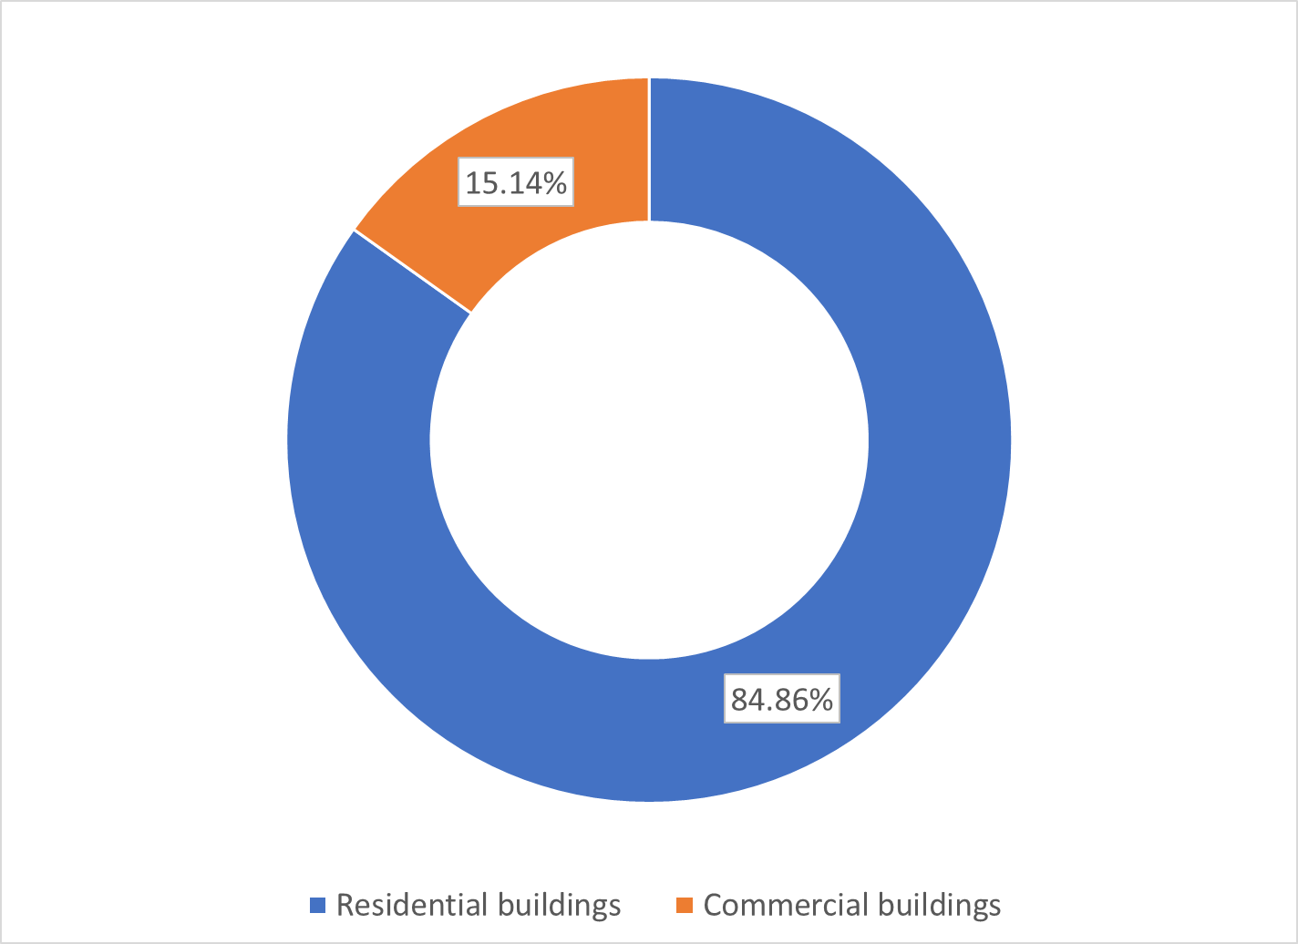
Slika 3.1 Structure of the total area of ​​buildings according to purpose
It can be noticed that the total area of ​​buildings is dominated by residential buildings with approximately 85% share. It is clear that this has a direct impact on the share in total energy consumption.
Data on public buildings are somewhat more accessible, especially when it comes to buildings managed by the municipality.

Town-owned buildings
In addition to the building of the Municipality, the buildings of all public institutions on the territory of the Municipality are also included here, and these are also primary and secondary schools, a health center and a house of culture. An overview of their characteristics is given below (Table 3.2).
Table 3.2 Overview of basic characteristics and energy consumption of public buildings on the territory of the Municipality of Tuzi in 2019
 | Number of facilities | Surface [m²] | Electricity consumption [kWh/year] | Fuel oil consumption [l / year]
Municipality building | 1 | 1423 | 115.308 | 0
Health centre | 1 | 737 | 100.022 | 0
Community Cultural Center | 2 | 1179 | 22.174 | 3.000
Elementary schools | 10 | 6177 | 607.861 | 24.000
High Schools | 2 | 3120 | 448.014 | 0
The total energy consumption in public buildings in 2019 amounted to 1,549.61 MWh (Table 3.3), and within that consumption, the dominant share belongs to facilities in the field of education (primary and secondary schools) with 75% share in total energy consumption (Figure 3.2).
Table 3.3 Energy consumption of public buildings in 2019
 | Electricity consumption [MWh / year] | Fuel oil consumption [MWh / year] | Total energy consumption [MWh / year]
Municipality building | 115,31 | 0,00 | 115,31
Health centre | 100,02 | 0,00 | 100,02
Community Cultural Center | 22,17 | 28,47 | 50,64
Elementary schools | 607,86 | 227,76 | 835,62
High Schools | 448,01 | 0,00 | 448,01
Total public buildings | 1.293,38 | 256,23 | 1.549,61

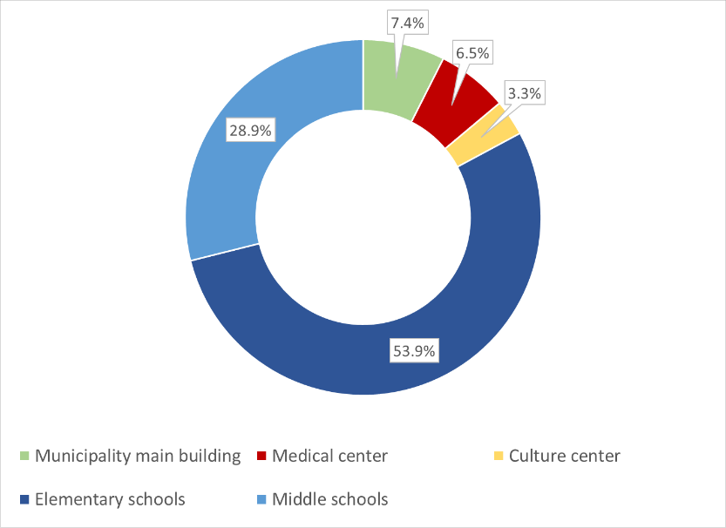
Figure 3.2 Structure of energy consumption in public buildings of the Municipality of Tuzi in 2019
It is necessary to emphasize that the building of the Municipality and the building of the Health Center are significantly represented in the energy balance because they are individual facilities, so in that sense they can be recognized as an address for potential measures to improve energy efficiency. Specific energy annual consumption for the building of the Municipality and the Health Center is 81 kWh / m2 and 136 kWh / m2. A national software for energy classification of buildings is being developed, which will give typical and recommended values ​​of this and other indicators of interest as one of the results, in order to assign an appropriate energy class to each building. If the recommended values ​​from the literature were observed, it could be pointed out that according to the specific energy consumption, the building of the Municipality is not energy intensive, ie has lower specific consumption than is usual for administrative buildings in Montenegro, while the Health Center is slightly above the recommended values ​​for medical facilities. In any case, as the goal is to achieve energy close to a neutral building, it is clear that there is a lot of potential for energy efficiency measures in the public building sector.

Commercial and service sector buildings
The sub-sector of commercial and service sector buildings covers an area of ​​59,559.5 m2. Area data were obtained from the Real Estate Administration. As it is known, the real estate cadastre for the Municipality of Tuzi is not fully harmonized with all the needs of stakeholders, so it is insufficiently equipped with the necessary data for the needs of analyzing the area and purpose of buildings in the Municipality of Tuzi, in order to model energy consumption by building sectors. The alternative was to survey all commercial entities in order to gather all the information, and as this is an extremely extensive and time-consuming job, this was not done. It is to be expected that after the development of the national software for energy categorization of buildings, and with some improvements in the information base on buildings currently available from the cadastre, sufficiently reliable monitoring of energy consumption in all subsectors of the building sector.
When it comes to energy consumption in this sector, it is easiest to collect data from the Electricity Supplier, but this requires knowledge of consumer numbers that correspond to all facilities of the commercial sector because the supplier does not monitor electricity consumption by categories recognized by this planning document.
In order to estimate the total energy consumption of the building sector, based on typical values ​​of specific energy consumption for commercial buildings in Montenegro, the total energy consumption can be estimated at 8,934 MWh / year. As it is a commercial sector, electricity is assumed to be the dominant energy source.

Residential buildings
According to the available data from the real estate cadastre, it is estimated that the area of ​​buildings corresponding to residential buildings is 333,857.9 m2. The total number of residential buildings on the territory of the Municipality of Tuzi is 1,572. Individual housing facilities dominate. There is currently no standardized collection of data on energy consumption in the residential sector. EPCG Supply, which is responsible for electricity supply, has the most reliable data on energy consumption. Data on the remaining energy sources used are collected through a survey on a selected sample.
As the preparation of national software for energy certification of buildings is currently in the process, the first phase of data collection for some typical facilities from all climate regions of Montenegro has already been completed. The municipality of Tuzi is associated with the region to which the Capital Podgorica belongs with the coast due to the extremely warmer climate in relation to the central and northern region of the country. For this region, the share of the following energy sources in the residential sector was recognized (Table 3.4): electricity, firewood, liquefied petroleum gas and a small share of coal.
Figure 3.3 Structure of energy consumption in the residential sector in 2019
Residential buildings | Energy consumption [kWh / year]
 | Electricity | Firewood | LPG | Coal | Total
 | 25.640,21 | 13.913,42 | 1.550,07 | 227,34 | 41.331,04

It is obvious that electricity consumption dominates in the residential sector (approximately 62%), but firewood also has a significant share (approximately 34%). LPG has a small share and insignificant coal (Table 3.4).
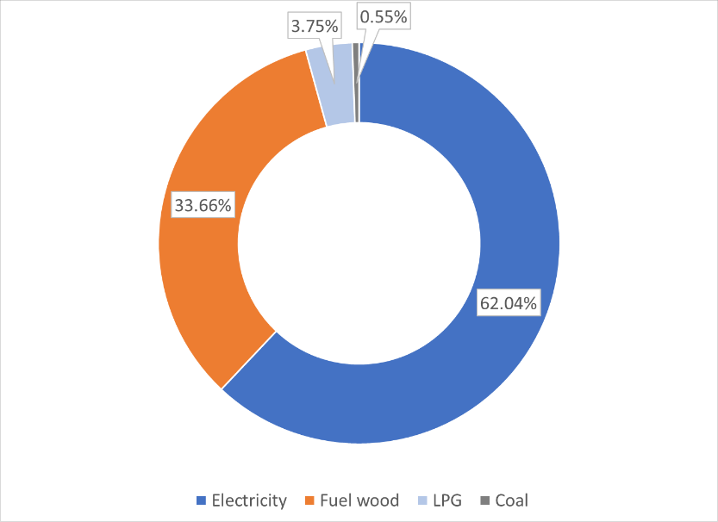
Figure 3.3 Structure of energy consumption in the residential sector
All energy sources except electricity are used predominantly to meet the needs for thermal energy (space heating, hot water preparation and cooking). On the other hand, electricity is also used to meet the needs for thermal energy, especially in the region to which Tuzi and the Capital belong. It is estimated that about 40% of total electricity consumption meets the needs for heat in this region. However, it should be emphasized that it is common for only approximately 30% of the usable area of ​​residential buildings to be heated and that only approximately 5% of buildings have a heating system for the entire usable area (according to statistical analyzes performed to prepare a national building inventory).

Analysis of total consumption in the building sector
Summarizing all subsectors, the energy consumption balance for the building sector was obtained (Table 3.5). The total energy consumption in the base year is 51,814.57 MWh. Typically, the largest share of energy consumption is in the residential sector (approximately 80%), followed by commercial buildings
Table 3.5 Total annual energy consumption in the building sector
Sector | Energy consumption [kWh / year]
 | Electricity | Firewood | LPG | Coal | Fuel oil | Total
Residential buildings | 25.640,21 | 13.913,42 | 1.550,07 | 227,34 | - | 41.331,04
Public buildings | 1.293,38 | - | - | - | 256,23 | 1.549,61
Commercial buildings | 8.933,93 | - | - | - | - | 8.933,93
Total | 35.867,51 | 13.913,42 | 1.550,07 | 227,34 | 256,23 | 51.814,57

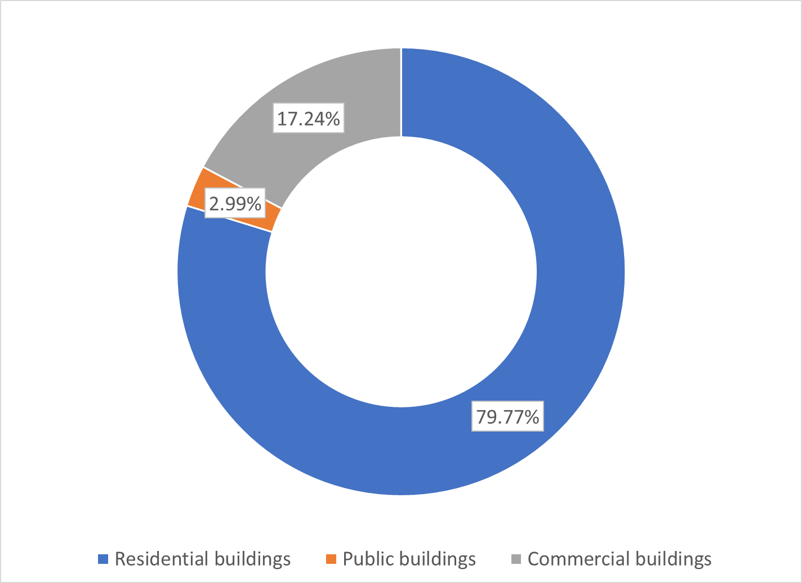
Figure 3.4 Structure of energy consumption by building subsectors
Public buildings have the smallest share in energy consumption, and thus the smallest potential global effect of energy efficiency measures, but due to organizational characteristics, in this subsector of buildings the implementation of energy efficiency measures is most effective, so the measures start using this subsector. Of course, the greatest long-term global effect is achieved by involving citizens in the process of implementing measures on their own facilities.

Analysis of energy consumption in the public lighting sector
Since the founding of the Municipality of Tuzi, the Town Service "Komunalno Tuzi" has taken over all the responsibility regarding the maintenance and plans for the expansion of public lighting. The fact that the management and operation of public lighting is centralized facilitates the collection of data and monitoring of the quality of public lighting, ie the identification of measures that can improve energy efficiency.
Currently, there is no register of lighting in the form of a geographic information system (GIS), so the introduction of the same in the future would further improve the quality of public lighting.
Public lighting facilities consist of power supply devices, cables (underground or overhead), poles, lampholders, lamps, light sources as well as control and regulation devices. Public lighting facilities are supplied from the distribution network from 10 / 0.4 kV substations. Measuring points are located in separate cabinets or as a field of public lighting in the low-voltage block of the substation itself. The complete topology of the public lighting network depends on the layout and size of the town units as well as the layout of the substations or distribution cabinets from which they are supplied.
The control of public lighting is done by means of astronomical switching clocks for control depending on the sunset and sunrise. Public lighting works on average about 4,360 hours a year.
The number of light bulbs in the territory of the Municipality of Tuzi is 3,500, while the number of measuring points is 62. Different types of lamps have been installed in the territory of the Municipality of Tuzi, more precisely lamps with a light source (70 W, 100 W, 150 W and 250 W), and lamps with LED light source (LED40, LED50 and LED 120). In relation to the total number of lamps in the Territory of the Municipality of Tuzi, 80% are lamps with a sodium light source.
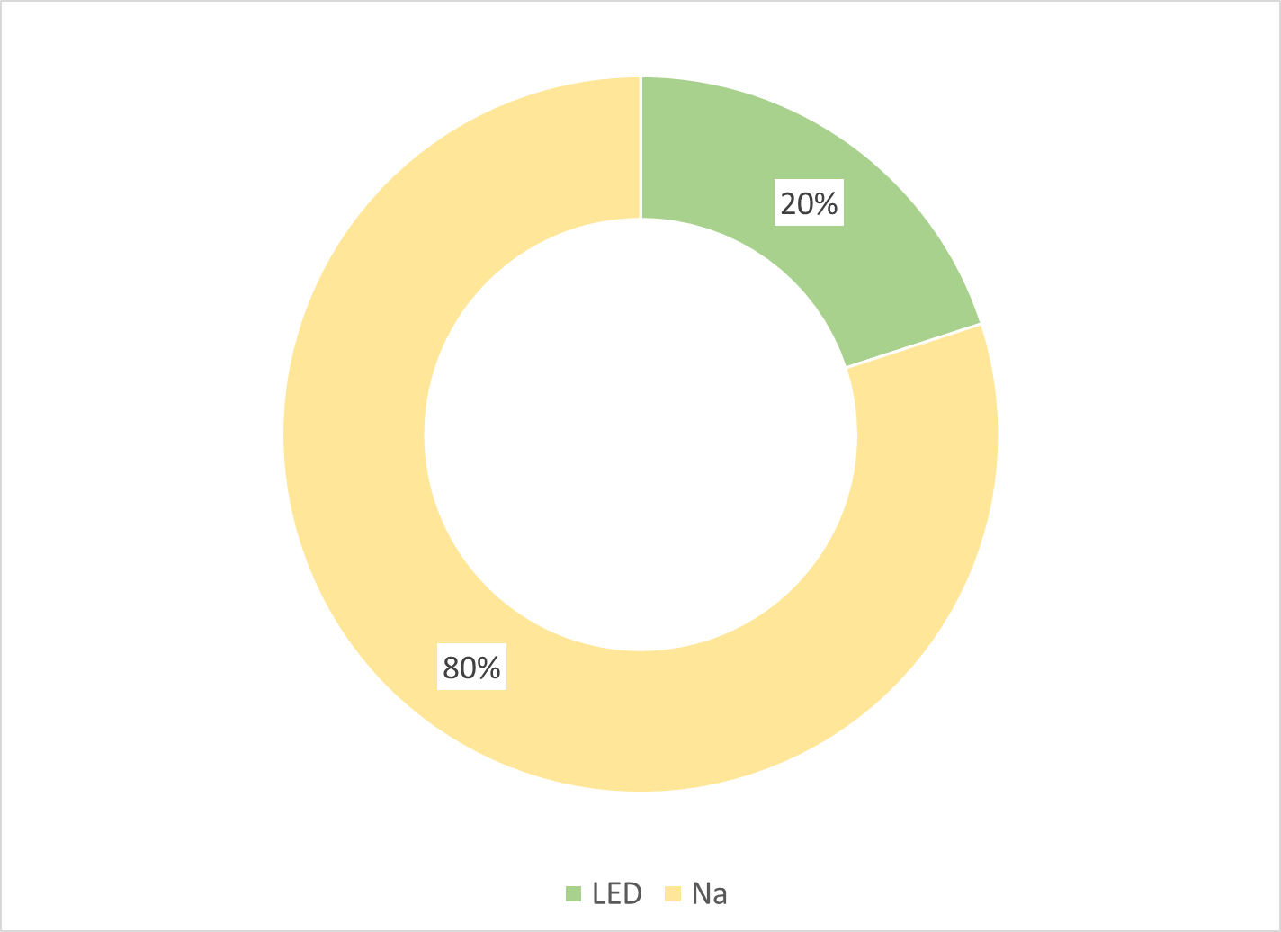
Figure 3.5 Structure of light bulbs used in public lighting according to the type of light source
The total annual electricity consumption for public lighting is about 1,400 MWh. As the Municipality of Tuzi relatively recently received this status, historical data on electricity consumption for public lighting were contained in data collected integrally for the Capital Town of Podgorica. Observing the historical trend of public lighting consumption in that period, one can notice the stagnation of consumption with moderate growth in certain years due to the development of infrastructure. During the period when the Municipality of Tuzi was part of the Capital, the share of electricity consumption for public lighting corresponding to the Municipality of Tuzi in the total electricity consumed for public lighting of the Capital is approximately 10%.

Analysis of energy consumption in the transport sector

Town administration vehicles
The town administration has 6 passenger cars, of which 3 are under 6 years old, and the oldest 2 were produced in 2008. All vehicles have a volume below 1,900 cm3 and use diesel as fuel. The town administration also has one truck. Total diesel consumption in 2019 and 2020 was 16,511 liters and 11,822 liters, respectively. It is evident that during 2020, there was a significant reduction in fuel consumption.
The energy value of diesel consumption by town government vehicles is 166.52 MWh and 119.22 MWh for 2019 and 2020, respectively.

Public transport
In the area of ​​the town of Tuzi, there are possibilities for public transport to take place by bus, taxi and train. However, only taxi transport has the role of public transport. Bus transport has the role of exclusively intercity passenger transport (to Podgorica) in the form of 2 lines that are permanently maintained during the year, except during school holidays when only one line is in operation. There is 1 bus on each of the mentioned lines.
The Podgorica-Shkodra railway runs along the entire territory of the municipality of Tuzi, with a railway station and a customs office in Tuzi, which is currently used exclusively for freight transport (Figure 3.6). It is planned to start railway passenger transport on the route Tuzi - Shkodra - Tuzi within the IPA projects in cooperation with the Ministry in charge of transport.
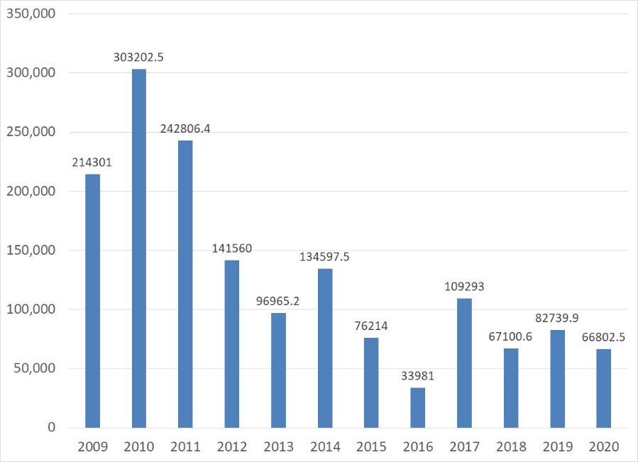
Figure 3.6 Freight transport on the route Podgorica-Tuzi [tone]
The total number of registered buses on the territory of the municipality is 7, of which 4 are registered by transport companies, while the remaining 1 is a school bus, 1 is owned by a religious organization and 1 is privately owned.
The annual fuel consumption for the maintenance of the mentioned intercity bus lines is 66,500 liters of diesel. Since the beginning of the pandemic, only 1 bus has been operating and had a consumption of 40,150 liters of diesel. The corresponding energy values ​​are: 670.66 MWh and 404.92 MWh respectively. The total number of passengers per year is 64,000 (2019) and 52,500 (2020).
Data on organized taxi transport on the territory of the Municipality of Tuzi were not available, as well as the associated fuel consumption.

Town road transport
The total number of registered vehicles in 2020 was 4184 and that is about 2% in relation to the total number of registered vehicles in Montenegro. The structure of the vehicle fleet in the territory of the Municipality of Tuzi is dominated by passenger cars (Table 3.6) with approximately 87.5% share in the total number of vehicles, which is slightly above the share of passenger cars in the total number of vehicles in Montenegro (86.2%). The average age of the vehicle fleet is 16 years.
Table 3.6 Fleet structure by type of vehicle for 2020
Passanger vehicle | Bus | Truck | Van | Motorcycle | Trailer | Agri. tractor | Special vehicles | Total
3661 | 7 | 403 | 1 | 18 | 56 | 10 | 28 | 4184

Historical data on the number of registered vehicles for the Municipality of Tuzi were not available due to the relatively recent acquisition of the status of a municipality, so these data were combined within the data for the Capital. However, on the trend of changing the number of vehicles in the previous period, it is possible to draw conclusions from historical data at the level of Montenegro (Figure 3.7).
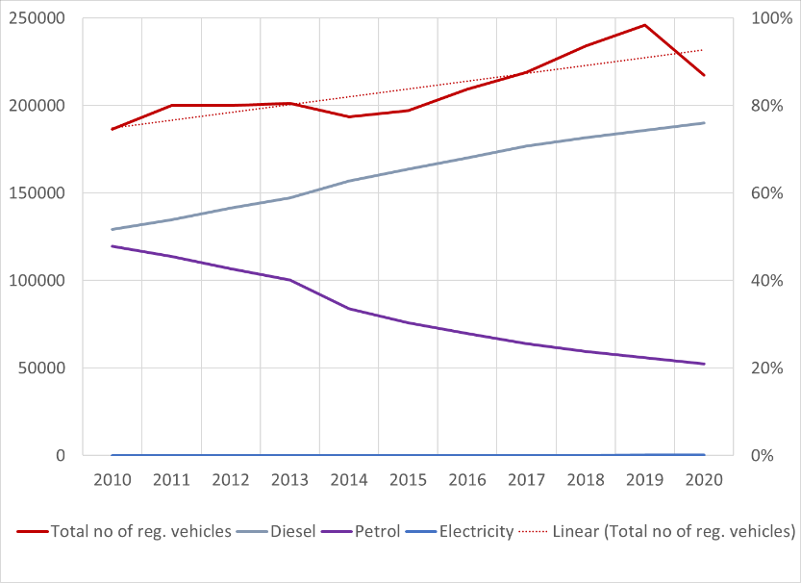
Figure 3.7 Trend of change in the total number of registered vehicles and their share by fuels of interest
So, from 2010 until today, the growing trend in the number of registered vehicles is clearly visible. A slightly more noticeable decline in the number of vehicles is seen in 2020 due to the pandemic, but it is to be expected that the recognized trend will continue. Also, the same figure shows the trend of changing the share of vehicles with selected fuels. The strong growth in the share of vehicles using diesel as a fuel from 2010 to the present is more than obvious. Thus, with the practically equal representation of vehicles with diesel and gasoline as propellants in 2010, in 10 years there has been a drastic substitution of propellants in the fleet of Montenegro, and today vehicles that use diesel have a share of almost 80% in the total vehicles. The main reasons for this are economic in nature (lower fuel price and higher vehicle economy), however this results in an extremely adverse impact on the environment and climate change. The precise structure of the vehicle fleet by motor fuels is given in the figure below (Figure 3.8).
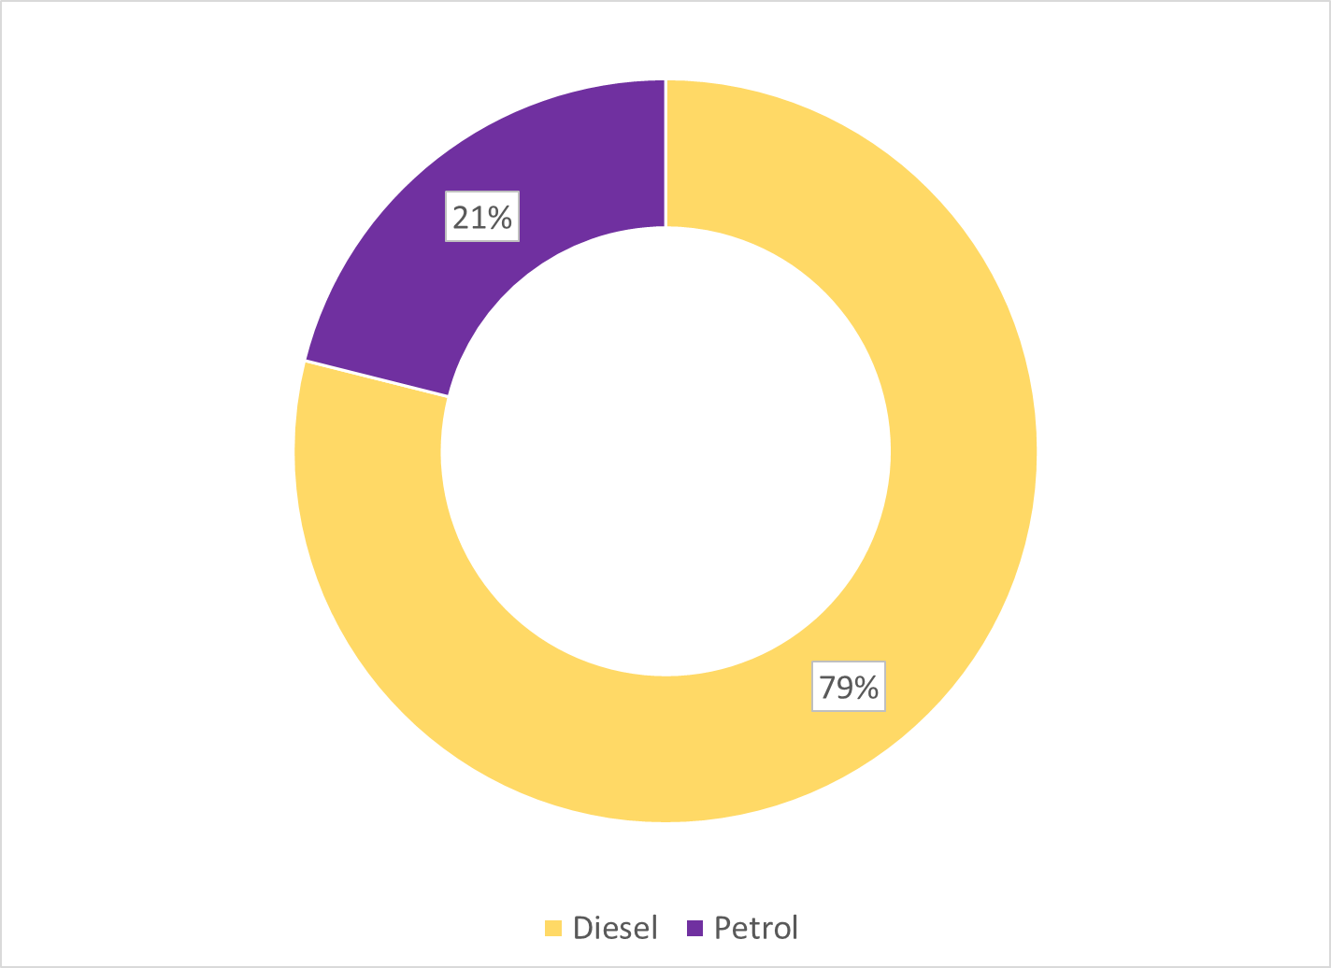
Figure 3.8 Vehicle structure by type of fuel for Montenegro in 2020
The fleet of the Municipality of Tuzi in 2020 can be said to correspond to the same structure when it comes to fuels as for Montenegro.
Private vehicles dominate in the fleet of the Municipality of Tuzi with 87.4% (Figure 3.9), while commercial vehicles (vehicles owned by economic entities) have a share of 12.4%. Vehicles owned by public institutions have a very small share of 0.2%.
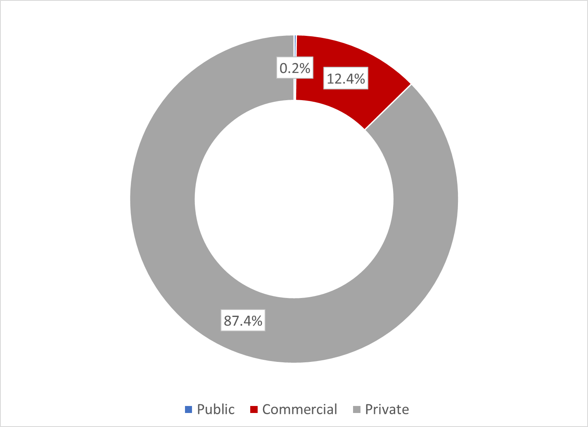
Figure 3.9 Structure of the vehicle fleet according to the purpose of the vehicle
Based on the insight into the type and age structure of vehicles registered in the Municipality of Tuzi, as well as statistical data on the associated characteristics of fuel consumption (GFEI, IEA) in the transport sector, the total fuel consumption in the transport sector of Tuzi Municipality was estimated (Figure 3.10).
Table 3.7 Overview of total fuel consumption in the Municipality of Tuzi
Fuel type | Gasoline |  | Diesel
 | [Liters] | [MWh] | [Liters] | [MWh]
2020 | 664.698 | 6.381,1 | 2.368.856 | 23.890,18

Figure 3.10 Structure of motor fuels according to energy value
The total energy value of annual fuel consumption is 30,271 MWh and similarly to the share of vehicles in the total fleet, diesel fuel dominates with almost 80% share.
Table 3.8 Energy consumption in the transport sector
 | Gasoline | Diesel | Total
Town administration vehicles |  | 119,22 | 119,22
Public transportation |  | 670,66 | 670,66
Town road transport | 6.381,10 | 23.890,18 | 30.271,29
Total transport sector | 6.381,10 | 24.680,07 | 31.061,17

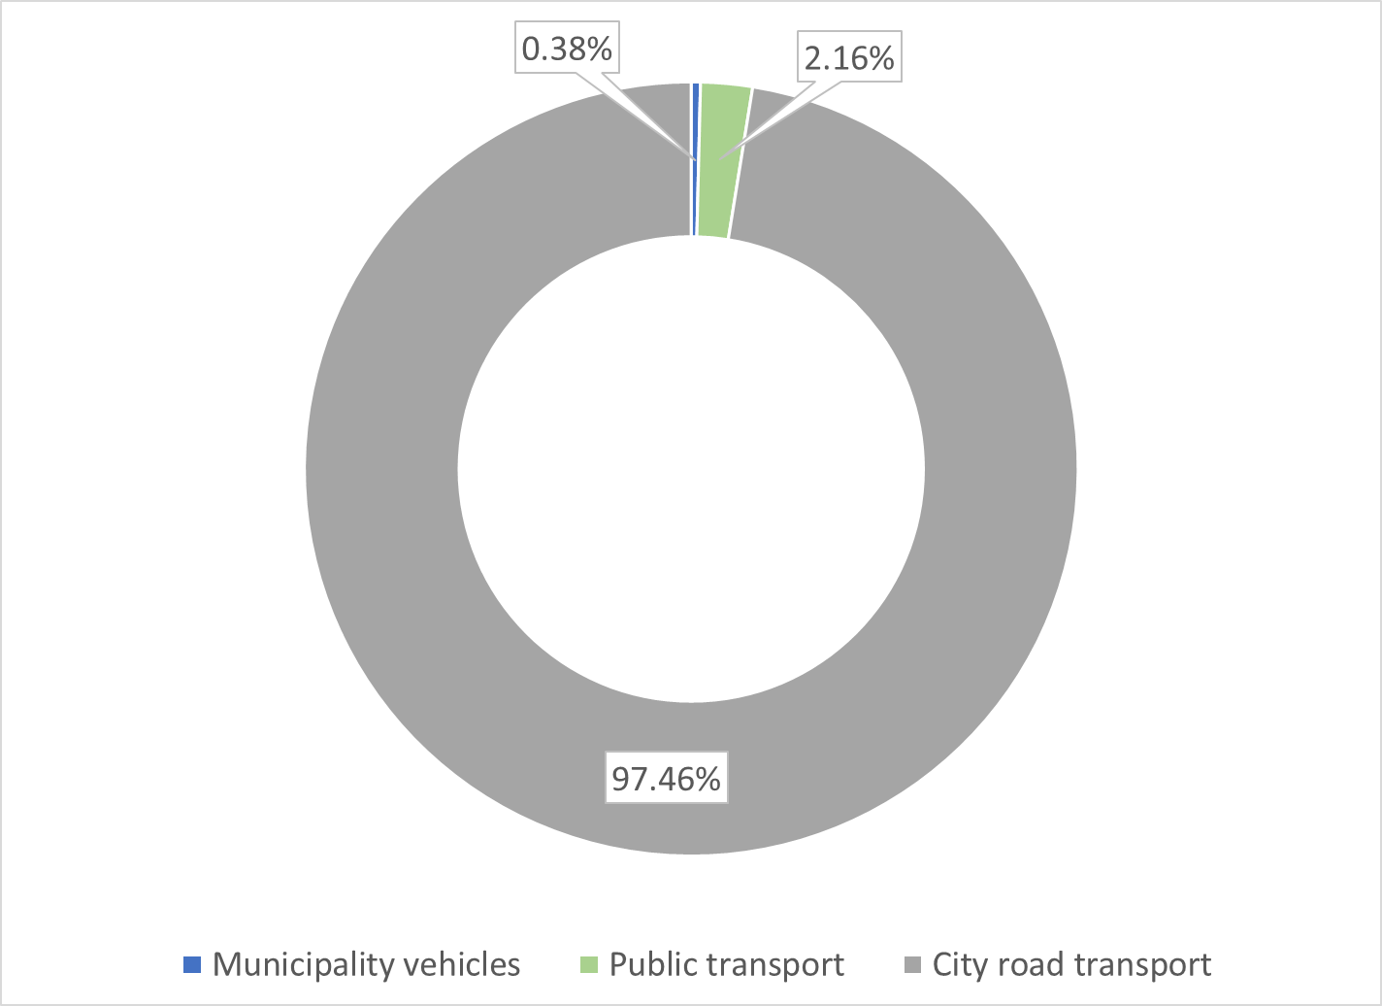
Figure 3.11 Share of subsectors in total energy consumption of transport sector
It is planned to install a charging station for electric vehicles with a simultaneous power of 34 kW in the parking lot of the Municipality building, as well as to build a gas station Eco under construction, which is under construction after the bridge over the river Cijevna at Karabuško polje it is a candidate for the UNDP project) a fast station for charging electric vehicles with a simultaneous power of 50 kW or more.

Analysis of the total energy consumption of the Municipality of Tuzi
An overview of total energy consumption in sectors and subsectors for the reference year is given in the table below (Table 3.9).
Table 3.9 Total energy consumption by sectors in the reference year
Buildings | Residential buildings | 41.331,04 | 51.814,57
 | Public buildings | 1.549,61
 | Commercial buildings | 8.933,93
Public lighting |  | 1.400 | 1.400
Transport | Town administration vehicles | 119,22 | 31.061,17
 | Public transportation | 670,66
 | Town road transport | 30.271,29
Total |  |  | 84.275,74

The total annual consumption of the sector of interest for this plan is 84,275.74 MWh. The intensity of energy consumption is highest in the building and transport sectors, which together account for over 98% of total consumption. Among subsectors (Figure 3.12), residential buildings and road transport stand out the most in terms of energy consumption, which together make up approximately 85% of consumption, so it is clear that measures targeted for these subsectors have the greatest effect on total energy consumption.

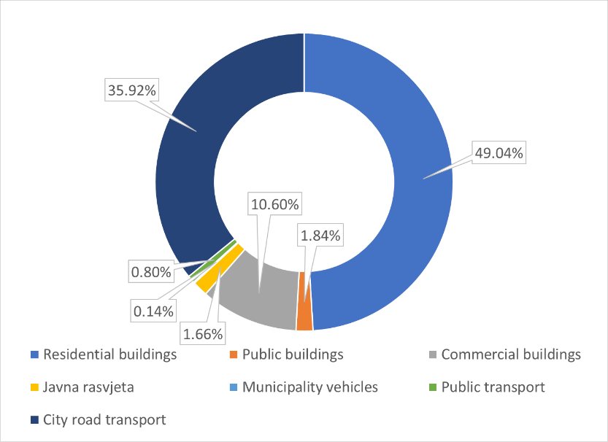
Figure 3.12 Structure of total energy consumption by subsectors in the reference year

REFERENCE INVENTORY OF EMISSIONS
As the Municipality of Tuzi has recently received the status of a municipality, it is a process of personalized collection of statistics and data of interest concerning the municipality itself, still in development, and the establishment of a reliable information base for the preparation of such and related plans is still expected. Collection of historical data was possible only for a part of the necessary information, but as other necessary data for the development of this plan for a further period in the past were contained within the data concerning the Capital, it was not possible to separate them within the deadline for this document. As a result, and taking into account the fact that 2020 cannot be taken as a typical year, 2019 was taken as the reference year for inventory purposes.
According to Monstat data, the estimated number of inhabitants in the middle of 2019 for the municipality of Tuzi was 12,371 inhabitants. According to these data, it can be concluded that there has been a slight increase in the population compared to the 2011 census.
Emission factors for identified energy sources are taken from the IPCC manual, while for electricity the national emission coefficient derived from the production mix of power plants is used, which was used when reporting on CO2 emissions in Montenegro (Table 5.1).
Table 4.1 Emission factors
Type of energy source | Emission factor tCO₂/MWh
Electricity | 0,34
Fuel oil | 0,276
LPG | 0,227
Gesoline | 0,249
Diesel | 0,267
Firewood | 0

Building sector
Taking into account the presented energy consumption balances and the stated emission factors, it is possible to estimate the total CO2 emissions for the building sector of the Municipality of Tuzi (Table 4.2). It can be noticed that, similarly to energy consumption, the residential sector has a dominant share in CO2 emissions (Figure 4.1).
Table 4.2 Total CO2 emissions by building subsectors (tCO₂)
 | Electricity | TNG | Coal | Fuel oil | Total
Residential buildings | 8.717,67 | 351,87 | 82,87 |  | 9.152,40
Public buildings | 439,75 |  |  | 70,72 | 510,47
Commercial buildings | 3.037,53 |  |  |  | 3.037,53
Total | 12.194,95 | 351,87 | 82,87 | 70,72 | 12.700,41

It should be emphasized that all emissions are conditioned by the dominant presence of electricity in the energy balance, so with the expected future improvement of the production mix in Montenegro there will be a spontaneous reduction of CO2 emissions at the state level, and thus the municipality. Then, when it comes to CO2 emissions, those sectors that use other energy sources that are particularly emission-intensive, such as fossil fuels, will come to the fore. Precisely to avoid this, it is necessary to plan the substitution of fossil fuels with cleaner and more affordable alternatives.

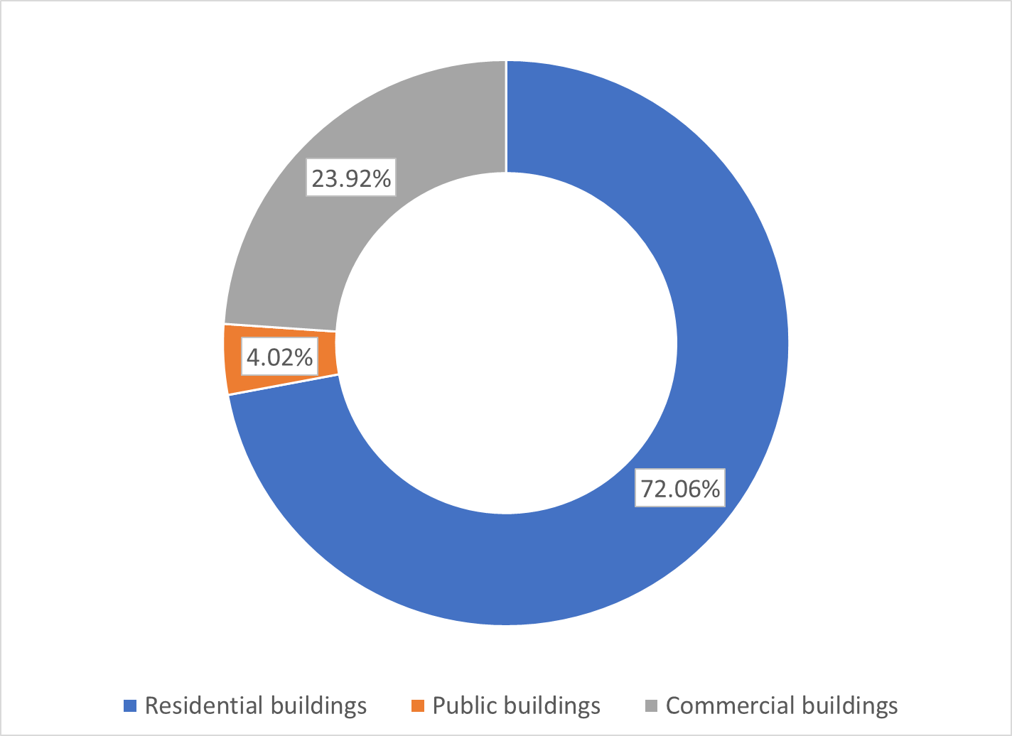
Figure 4.1 Structure of CO2 emissions by subsectors of buildings

Public lighting sector
CO2 emissions from the public lighting sector in the town of Tuzi result from the electricity consumption of the public lighting network. CO2 emissions in the public lighting sector in the reference year were 476 tCO₂.

Transport sector
Taking into account the emission factors and the previously presented balance of energy consumption, the emissions of the transport sector by subsectors for the reference year were estimated (Table 4.3). Practically all emissions in the transport sector correspond to urban road transport (above 97%). Public transport has a very small share, but this is expected due to its poor development.
Table 4.3 Total CO2 emissions by transport subsectors (tCO₂)
 | Gasoline | Diesel | Total
Public administration vehicles |  | 31,83 | 31,83
Public transportation |  | 179,07 | 179,07
Town road transport | 1.588,89 | 6.378,68 | 7.967,57
Total transport sector | 1.588,89 | 6.589,58 | 8.178,47

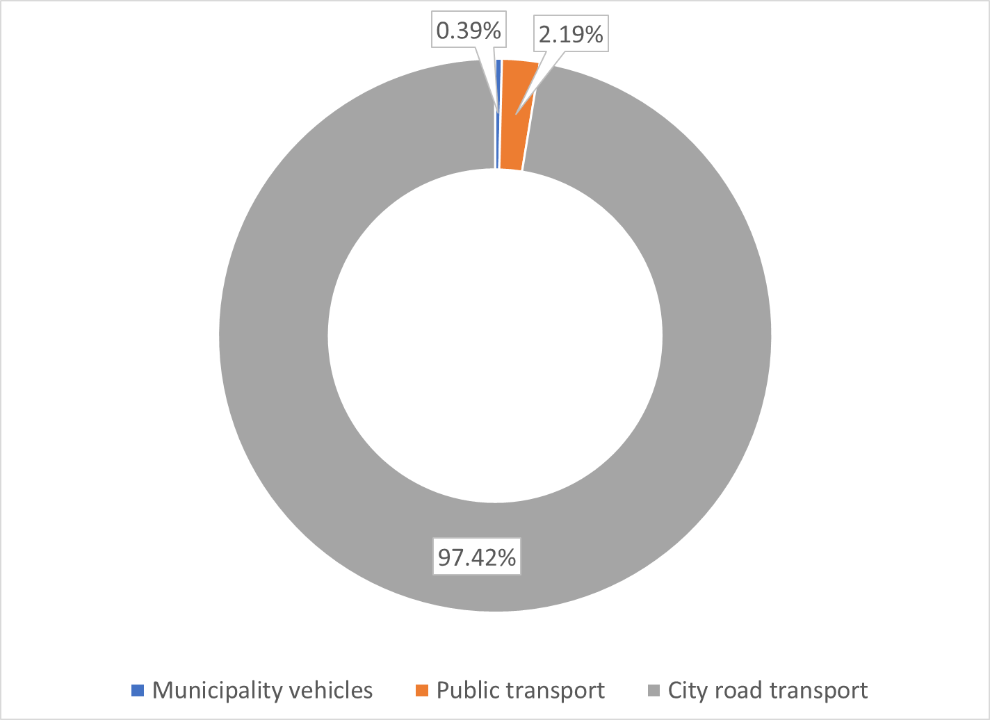
Figure 4.2 Structure of CO₂ emissions by transport subsectors

Total emissions in the reference year by sectors
Summarizing all the results calculated for the sectors, it is possible to obtain an overview of total CO2 emissions (Table 4.4). It can be noticed that similarly to energy consumption, the building sector is dominant (approximately 59%), but it is not as dominant in relation to the transport sector as when it comes to energy consumption. The reason is the significant presence of firewood in the energy balance of buildings, which does not emit CO2. This circumstance should be especially taken into account when defining measures aimed at reducing CO2 emissions in the building sector.
Table 4.4 Total CO₂ emissions by sectors
Sector | Emission [tCO₂]
Buildings | 12.700,41
Public lighting | 476
Transport | 8.178,47
Total | 21.354,88

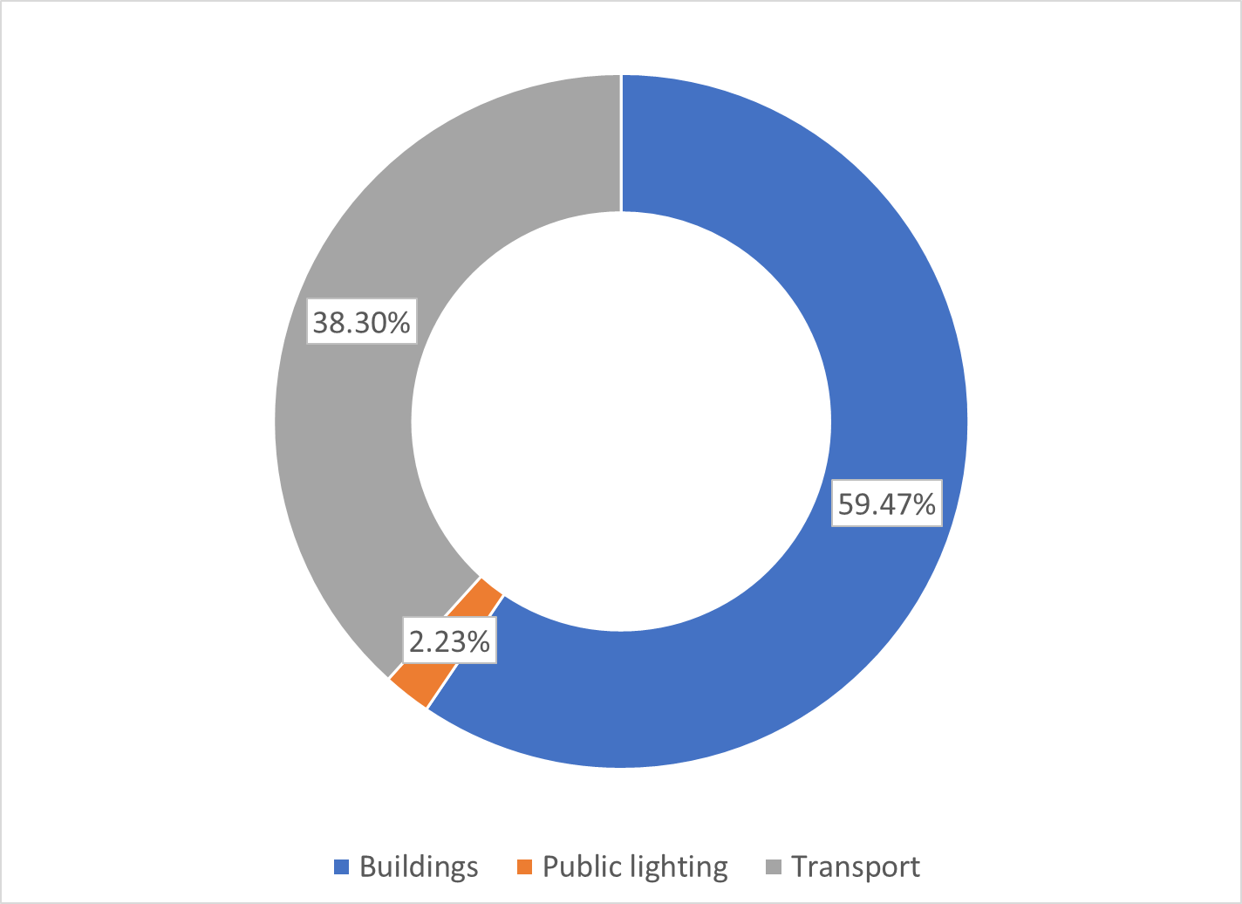
Figure 4.3 Structure of CO2 emissions by sectors of interest for the reference year
Therefore, measures to reduce CO2 emissions are especially important in the building and transport sectors, especially electromobility, but also the activation of railway transport, but it is important to keep in mind the way electricity is produced, ie it is important to influence the energy mix, a higher share of renewable energy sources in order to reduce the national emission factor, which is linked to the electricity system. This would affect all sectors because electricity is the dominant energy source.
Taking into account the amount of emissions in the reference year, it is clear that the target for 2030 is thus set to reduce emissions to at least 12,812.93 tCO₂. Appropriate measures in those sectors that are characterized by the most intensive emissions, ie. use of energy sources with a significant impact on emissions: fossil fuels, but also electricity taken from the public energy supply system as long as the energy mix is ​​unfavorable in terms of the participation of renewable energy sources. A fixed emission factor for electricity will be assumed here, although it is clear that various strategies at the national level are aimed at further integration of renewable energy sources and that the national emission factor of the Montenegrin electricity system (depending on the generation mix) will decline over time of the aforementioned goal.

RISK AND VULNERABILITY ASSESSMENT TO CLIMATE CHANGE

Climate of the town of Tuzi
The town of Tuzi is located in the area of ​​the fertile lowlands of the Zeta plain. According to Köppen's classification, the climate in this area is moderately warm rainy (Csa). Summers are hot and dry, autumns are warmer than springs, and winters are relatively mild and rainy. During the winter the temperature is slightly lower than the coastal places at approximately the same latitude, and during the summer it is slightly higher. Due to the higher degree of continentality and great clearness of the sky in summer, the soil and air are very hot, so this area is then the warmest in Montenegro. The highest ever measured maximum daily temperature was 44.8 ⁰C in August 2007 in the capital Podgorica, about 10 km from Tuzi. During the heat wave in 2003, there were as many as 122 tropical days in this lowland (in Podgorica).
The proximity of Skadar Lake and the warm Adriatic Sea, terrain configuration, soil composition, vegetation cover and atmospheric circulation contribute to such a climate. Bearing in mind that the neighboring meteorological stations in Podgorica and Golubovci are located in the same climate area, at a distance of about 14 km, and the difference in altitude of about 16 m above sea level (meters above sea level), and that there are no climate modifiers between them that would significantly affect meteorological elements, air temperatures deviate slightly from each other, as well as precipitation. Mean daily temperatures are about 1 ⁰C lower than in Podgorica, and extreme temperatures are up to about 2 ⁰C lower.
Therefore, it can be said that in the warmest month of July, the average monthly air temperature in Tuzi is 26.5 ⁰C, and in the coldest month in January, the average monthly temperature is 4.9 ⁰C. The average annual temperature is 15.2 ⁰C. The mean monthly values ​​of extreme temperatures are shown in the figure (Figure 5.1). They range from 0.5 ⁰C to 10.1 ⁰C in January as the coldest month, while the mean minimum temperatures are slightly higher in July 20.1 ⁰C than in August, and the maximum slightly higher in August 32.3 ⁰C than in July.
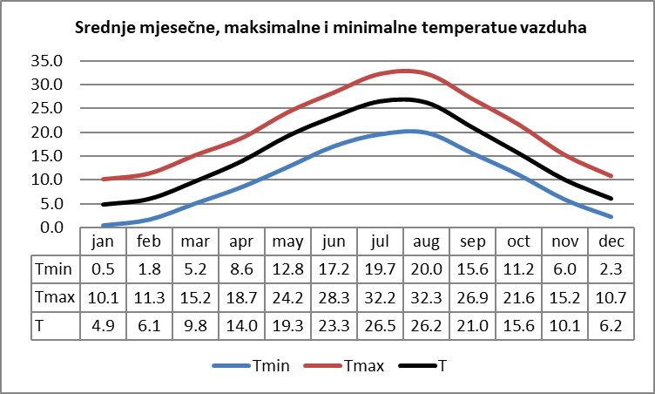
Figure 5.1 Annual course of mean monthly T, mean maximum Tmax and mean minimum temperatures Tmin in Golubovci for the period 1981-2010.
The dry period is summer, and the rainy period is late autumn and winter. The driest month is July which has an average of 25 mm of rain, and the rainiest November with 217 mm. The average annual rainfall is 1505 mm. Heavy rains ≥ 20 mm, have the highest intensity in autumn and early winter on average 44 mm / day, and during the year about 43.6 mm / day. The highest intensity is around 47 mm / day in September, due to the smaller number of days with precipitation.
The duration of sunshine during the year averages 2,600 hours, which means that the Zeta Valley is rich in sun, not only in Montenegro, but also in Europe.
The prevailing winds are bora - north and wide - south. The north wind brings cold and dry weather, and the south warm and rainy. The average annual wind speed is 2.7 m / s. and tends to decrease from 1980 to 2020 (Figure 5.2). In general, the mean wind speed has two maximums, one in March 3.1 m / s and the other in July 3 m / s, and is higher during spring and summer 2.8 m / s. Observed by direction, the north wind has the highest average speed of about 3 m / s. A stormy wind accompanied by heavy rains leading to flooding is southerly.

Figure 5.2 Mean annual (graph above) and mean monthly wind speeds (graph below) according to data at the meteorological station in Golubovci
In winter, strong winds with stormy to hurricane speeds from the northern quadrant dominate. They occur due to the passage of a cyclone and in a synoptic situation that causes a storm. During the summer, stormy winds occur during local instability. They include extremely heavy rainfall that accompanies the town, lightning strikes and a drop in pressure.
Overview of the basic characteristics of the climate of the city of Tuzi for the period 1981-2010 according to the data from the meteorological station at the airport in Golubovci
Average annual air temperature: 15.2 ° C
Average annual rainfall: 1504.9 mm
Mean annual rainfall intensity: ≥ 20 mm; 43.6 mm / day
Average number of frost days: 34.3 days / year
Average number of tropical days: 70.2 days / year
Average number of days with snow cover: 3.9 days / year (1996-2010)
Mean max height of snow cover: 7 cm (1996-2010)
Average relative humidity during the year: 64%
Average annual duration of sunshine: 2600h
Average annual cloudiness: 47%
Average annual wind speed: 2.7 m / s
Climate classification according to Köppen Csa, according to Thorntwhite perhumid mesothermal 3
(C-moderately warm and humid climate, corresponds to the temperate zone, s-dry period in the warm and humid in the cold part of the year. The driest warm month has a total rainfall of less than 1/3 of the rainiest cold month; a - hot summers, medium monthly temperature of the warmest month of the year is higher than 22 ° C)

Observed changes in temperature, precipitation and extreme events
Climate monitoring and assessment show that Montenegro's climate is changing as a result of global climate change and variability. The clearest indicators are: a significant increase in air temperature, an increase in sea surface temperature and mean sea level, changes in extreme weather and climate events.

IPCC definition - variability and climate change
Climate variability - the way in which the climate fluctuates at (above or below the climatological normal) all time scales greater than a weather event. Such variability may be the result of natural (internal and external) and anthropogenic factors;
Climate change - changes in the mean state of the climate or its variability over a long period of time (typically several decades or more). The change can occur due to natural and anthropogenic factors (change in the composition of the atmosphere or land use).

Temperature
The average annual temperature has been growing since the mid-1990s in relation to the climatological normal 1961-1990. Its deviation in the period of the warmest decade so far 2010-2020 is + 1.6 ⁰C (Table 5.1).
Table 5.1 Mean annual air temperature by decades and its changes ∆1 and ∆2 (0C) in relation to the climatological normal 1961-1990 at the main meteorological stations Podgorica and Golubovci
 | Climate normal | Temperature deviations (⁰C)
DECADE | 61-90 | 51-60 | 61-70 | 71-80 | 81-90 | 91-00 | 01-10 | 11-20 | ∆1 | ∆2
Golubovci  33 mnv | 14.8 | 15.0* | 14.9* | 14.6* | 14.9 | 15.1 | 15.7 | 16.4 | +0.9 | +1.6
Podgorica  49 mnv | 15.3 | 15.5 | 15.4 | 15.0 | 15.4 | 15.8 | 16.3 | 17.0 | +1.0 | +1.7

Figure 5.3 Deviations of the average annual temperature in Podgorica in relation to the climatological normal 1961-1990.
(Interpolated value *, ∆1 - Deviation of the average annual air temperature for the decade 2001-2010 from the climatological norm 1961-1990; ∆2 - Deviation of the average annual air temperature for the decade 2011-2020 .. in relation to the climatological norm 1961-1990. ; mnv - meters above sea level)
Due to the shift of mean temperature values ​​to higher ones, the climate is warmer, with more frequent record maximum temperatures, higher minimum temperatures and therefore less cold weather (Figure 5.4). During the heat wave in August 2007 and 2012, 42.3 ⁰C and 42.5 ⁰C were measured in Golubovci, respectively. From 2015 to 2020, the average annual temperatures were in the category of extremely warm at the level of Montenegro.

Figure 5.4 Percentage of hot days Tx> = 90th percentile and warm nights Tn> = 90th percentile in Podgorica in relation to the climatological normal 1961-1990.

Precipitation
There is no significant reduction in the total annual rainfall. Within normal limits, precipitation increases in autumn and decreases in spring, summer, and winter. In statistical terms, there is a significant increase in September in the Zeta-Bjelopavlica region. Variability has been particularly pronounced in recent decades, indicating that the precipitation regime is taking on a more extreme character. An example of this is the extreme annual rainfall (2010, then 2013 and 2014, 2019, 2021) which was replaced by very severe droughts (2011-2012 and 2015, 2017, 2018, 2020).
The figure (Figure 5.5) presents the spatial distribution of the average annual rainfall for the period 1981-1990. and its deviations from the climatological normal. In the area of ​​the municipality of Tuzi, the average annual rainfall was about 9% lower than the climatological normal. This indicates the fact that there is a trend of decreasing average annual rainfall.
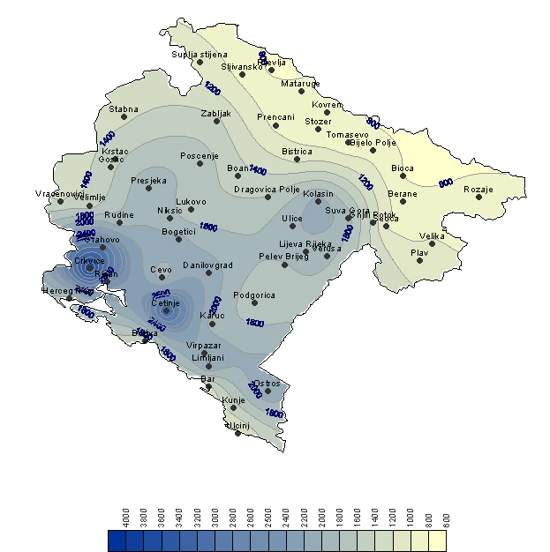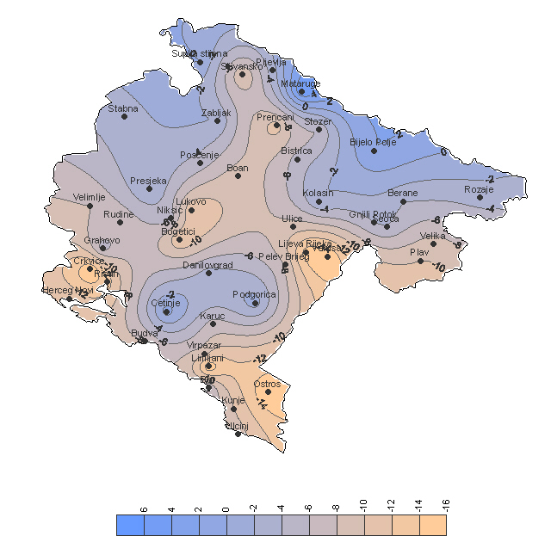
Figure 5.5 Spatial distribution of the average annual rainfall (left) for the period 1981-1990. and its deviations (right) in relation to the climatological norm 1961-1990 (Source: Second National Report of Montenegro according to UNFCCC)

Extreme weather and climate events
Observed extreme weather and climate events until 2019 (source Adaptation of the Capital Town of Podgorica to climate change) for the Zeta Valley area indicate:
- more frequent extremely high maximum and minimum temperatures, more frequent and longer heat waves;
- a large number of very warm days and nights;
- more frequent droughts accompanied by high temperatures and forest fires;
- interruption of the dry season by heavy rainfall;
- higher precipitation intensity, and
• more frequent occurrence of storms (cyclones) during the colder half of the year.
There is a statistically significant change in extreme temperatures. The length of heat waves is increasing, as is their frequency (Figure 5.6). Annual precipitation intensity ≥ 1 mm has a growth trend (Figure 5.7).
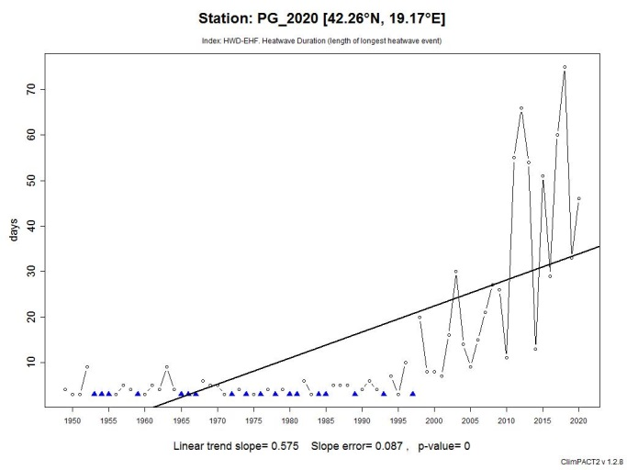
Figure 5.6 Length of the longest heat wave duration (left, HWD-EHF index) in Podgorica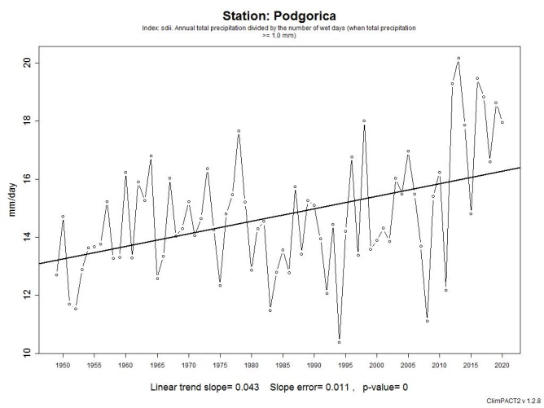
Figure 5.7 Annual precipitation intensity (mm / day) in Podgorica

Expected temperatures, precipitation and extreme events
Climate change projections were presented on the basis of the Third National Report of Montenegro according to the UNFCCC, which used the regional model NMMB, scenario RCP8.5 for the period 2011-2100.
The analyzes were observed in relation to the period 1971-2000, and the results were presented for each thirty-year period 2011-2040, 2041-207 and 2071-2100.

Temperature projections
According to the RCP8.5 climate change scenario, which assumes a continuous increase in the concentration of CO2 in the atmosphere during the 21st century, a further increase in air temperature can be expected. Climatic conditions would be characterized by a significant increase in the number of summer days, the number of tropical days and nights, which could have particularly negative implications for human health in the future. The total length and number of tropical waves will continue to grow until the end of this century. The number of days with frost will be significantly reduced, and the vegetation period will be longer.
Table 5.2 Projected changes in mean seasonal and annual temperatures for Tuzi
 |  | Temperature projections in relation to the reference period 1971-2100
 |  | Scenario RCP8.5
 |  | 2011-2040 | 2041-2070 | 2071-2100
Average annual temperature |  | +1,5 do 2°C | + 2.5 do +3°C | about +.5°C
Mean seasonal temperature | Winter | +2 do 2.5°C | about + 2.5°C | about +5.5°C
 | Spring | +1,5°C +2 °C | about + 2.5°C | +4,5°C do +5°C
 | Summer | about +2 °C | about + 3°C | about + 6°C
 | Autumn | +2 do 2.5°C | about + 2.5°C | about +5.5°C
Number of days with frost |  | -50% | -70% | -95%
Mean duration of heat waves |  | 2 times longer | 3-4 times longer | 10 times longer lasting
Average annual number of heat waves |  | 4 - 5 times more | 7-8 times more | 10 times more

Precipitation projections
Climate projections show that over time the climate will tend to have a more arid precipitation regime, with average negative anomalies at the annual level of -5% to -10%, primarily as a consequence of a possible reduction in summer precipitation. As the occurrence of snow in the area of ​​Zeta in the current conditions can be considered a relatively rare phenomenon, further change of climatic conditions, we can expect that there will be no snow in these areas. In the future, a reduction in the number of days with accumulated precipitation greater than 20 mm can be expected on average. On the other hand, during these days the precipitation accumulations may be higher in relation to the values ​​from reference period and therefore precipitation intensity. It can be expected that the number of consecutive days without precipitation will increase in the future, which will cause an increased risk of drought.
Table 5.3 Projections of changes in mean seasonal and annual precipitation, number of days with heavy precipitation, number of consecutive dry days and changes in snowfall
 |  |  | Precipitation projections in relation to the reference period 1971-2100
 |  |  | RCP8.5
 |  |  | 2011-2040 | 2041-2070 | 2071-2100
Average annual rainfall |  |  | to -5% | from -5% do -10% | from -5% do -10%
Average amount of seasonal precipitation |  | Winter | from -5% do -10% | to -5% | +10%
 |  | Spring | +5% | about -10% | -20%
 |  | Sumer | from -10% to -20% | -20% | -45%
 |  | Autumn | about +5% | from +5% to  +10% | +5%
Medium number of days with heavy rain (> 20mm) per year |  |  | -5% to -10% | -5% to -10% | -10%
Mean number of consecutive dry days (precipitation <1 mm) |  |  | to -5% | -20% | 50%
Snow | winter |  | -80% | -90% | -90%
 | November - April |  | -80% | -90% | -90%

Extreme wind - maximum speed
The modeling results indicate a slight decrease in the mean annual maximum wind speed in both scenarios (DNA, A1B and A2 scenario) and both time intervals. The possible reduction is about -5% compared to the climatological normal of 1961-1990.
In addition, an increase in intense extreme events in the summer is expected, such as thunderstorms followed by strong and stormy winds and intense rainfall, which certainly indicates a high degree of vulnerability of this area to damage caused by these extreme events.

Risk assessment and vulnerability to climate change

Observed extreme events - hazards
Natural hazard is a process or phenomenon that can cause loss of life, injury or other health hazards, property damage, social and economic disturbances or environmental degradation (UNISDR 2009).

Based on research conducted for the study "Analysis of the capital Podgorica on climate change", during which data were collected on the damage caused by climate change and extreme events - hazards, it can be concluded that the most important hazards:
- heavy rains leading to floods / floods;
- heat waves;
- droughts followed by forest fires;
- storms;
- hail.
Hazards such as floods and forest fires also have a transboundary impact.

Heat waves
Heat waves were recorded in Podgorica on several occasions during 2003, 2004, 2005, 2006, 2007, 2011, 2012, 2013 and 2014.
Records in the maximum daily temperature at the state level of 42.2 °C (August 2003), 44.8 °C (August 2007) and 44 °C (August 2012) were also measured in these periods.
Heat waves have caused increased heat stress in the population, with a particularly negative impact on the health of vulnerable groups (the elderly, children, people with cardiovascular and heart diseases and the mentally ill). In addition, there was a decrease in labor productivity, especially in the sectors of agriculture, infrastructure and construction, a decrease in other economic activities (trade; utilities), increased electricity consumption and water consumption.
The most affected were the urban parts of Podgorica, Tuzi and Golubovac, as well as town parks, forest park, block and linear greenery.

Drought
Period from 01.06. to 10.09.2003 was marked by drought, which developed into agricultural (adopted terminology). A very warm spring and an extremely warm summer contributed to this.
After a few years break, a new drought ensued which developed to hydrological after agriculture. In the period from 01.06. until 19.10.2007, the maximum number of consecutive days without precipitation was 56, which is the third record number and equal to the values ​​from 1988 and 1989. In 2007 it was extremely warm spring, summer and winter.
Extremely dry conditions were recorded throughout 2011. Drought developed to hydrological. The mean air temperature was above average for most of the year. November 2011 was the driest year since 1970. Very warm spring, extremely warm summer and autumn, and winter in the warm category.
During the summer season of 2012, very dry conditions prevailed. Due to the hydrological drought during the previous 2011, favorable conditions were created for large-scale forest fires. Spring was in the category of very warm, and extremely warm summer, autumn and winter.
Droughts have caused restrictions on the availability of drinking water, while agricultural production in suburban areas has suffered great damage. The water level in the rivers reached a minimum. Smaller streams have dried up. Damage to biodiversity has been recorded, and there has been a drying of vegetation less resistant to high temperatures, which has higher water needs. As a side effect of the drought, overheated asphalt surfaces further increased the air temperature. Green and park areas in the town, as well as gardens and backyards in suburban settlements were particularly affected. The operation of the wastewater treatment plant was also difficult.

Fires
As a consequence of the above-mentioned heat waves and dry periods, several large-scale fires were recorded in Podgorica, as follows: 04.08.2007, 24.08.2011, 16.07.2012, 24.07.2012 and 31.07.2013.
On that occasion, a larger area under forests was destroyed, increased smoke and the appearance of smog on the territory of the municipality of Podgorica were recorded, and great material damage occurred. Park-forests across the road from KAP, Gorica, Ćemovsko polje and Golubovci were particularly damaged. In the refugee / Roma settlement Konik - Camp I, 29 barracks burned down, and 150 families with a total of 800 people were left without accommodation.
Damages from fires in 2020 and 2021 in the municipality of Tuzi are shown in the table

Table 5.4 Fire damage in 2020 and 2021
Total fire damage in 2020 | 134.422 €
Total fire damage in 2021 | n/a

Heavy rains leading to floods / floods
Periodic flooding of certain parts in the Skadar Lake basin is especially pronounced in spring and autumn when the greatest intensities of precipitation. Then there are often floods in the Zeta Valley and the shores of Skadar Lake.
Extreme rains from December 2009 to January 10, 2010 caused serious material damage. A large number of houses in the area of ​​Skadar Lake and Ulcinj were flooded. About 1,100 people or 245 households were evacuated. The water level on Morača was 702 cm, which represents 44% of the maximum water level.
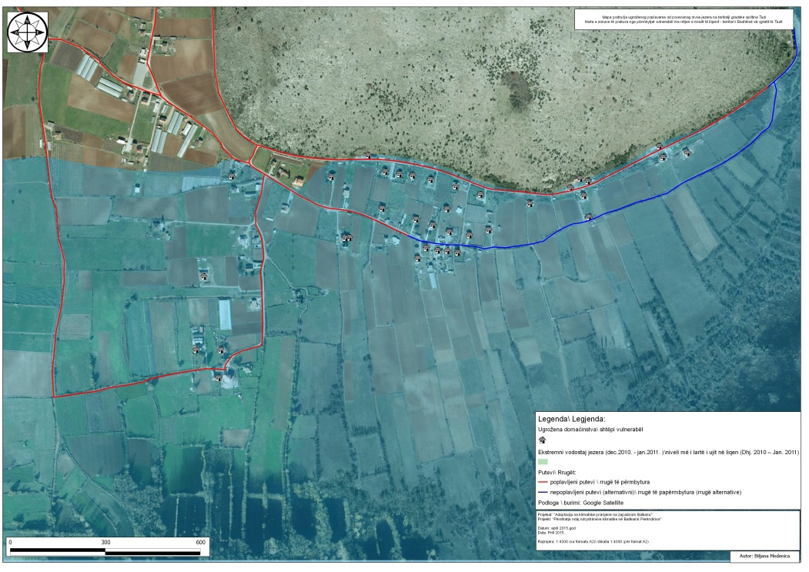
Figure 5.8 Vulnerable households at the extreme water level of Skadar Lake in the period from December 2010 to January 2011 (GIZ project Adaptation to Climate Change in the Western Balkans)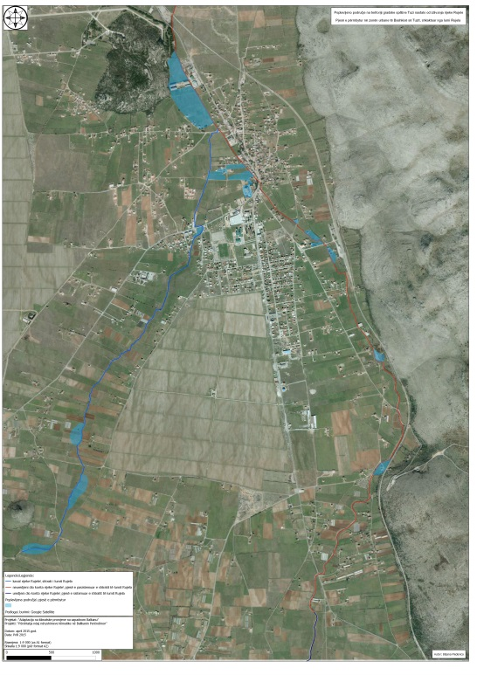
Figure 5.9 Flooded areas due to the overflow of the river Rujela from 30.11. to 01.12.2010. (GIZ project "Adaptation to climate change in the Western Balkans)
During three days, from 30.11. to 01.12.2010, heavy rainfall with over 100 l / m² was recorded. It was the largest flood ever recorded, bearing in mind that the measured water level at the Plavnica measuring station exceeded the level of Skadar Lake by 38 cm in January 1963, when the level of Skadar Lake reached the maximum recorded water level of 530 cm. The river Rujela, the river Cijevna and Skadar Lake overflowed. Strong cyclonic activity continued, followed by strong south wind and high air temperatures, which caused heavy rainfall (over 146 l / m²). The maximum recorded water level of Skadar Lake during this new flood wave was recorded on 04.12.2010 on HS Plavnica - 588 cm (highest ever measured value).
During 2012, they were recorded on two occasions: 27 and 28 August (heavy rains due to strong cyclonic activity from the Alps, 93 mm of rain fell) and 29.11.2012. year (in just over 24 hours, fell 157 l / m2, which is 66% of the average rainfall for November).
During the second half of March and the first half of April 2013, heavy rainfall followed again - heavy rain followed by a strong south wind, and on April 5, 2013.
The water level of 445 cm was measured in On January 21, 2014, due to heavy rainfall, the river Rujela overflowed again.
Damage from floods in 2020 and 2021 in the municipality of Tuzi are shown in the table:
Table 5.5 Flood damage in 2020 and 2021
Total flood damage in 2020 | 1.500 €
Total flood damage in 2021 | 31.605 €

Snowfall
Snow is a rare occurrence in the municipalities of Podgorica, Golubovci, Tuzi and other settlements of the Zeta Valley, and therefore represents extreme weather conditions. It was recorded in January 2005, and 2012 was especially snowy on several occasions: 01-08 February (snowfall with strong northeast wind and icy temperatures, the height of the snow cover reached over 50 cm), 11-24 February (up to 57 cm of total snow cover) and 11.12.2012 (15 cm of snow cover).
There was also snow from February 2 to 4, in 2014 (up to 32 cm in height of snow cover).
During the recorded extreme (rain and snow) precipitation, numerous residential and business buildings were flooded, and some streets were impassable. Road and air transport was interrupted. In extreme cases, schools and kindergartens were closed, and a state of emergency was declared (evacuation and care of the population and material goods). There was also a power outage in some parts of the town. An increase in turbidity and discoloration of water due to leaching was also registered, and drinking water from individual wells was unusable. There were also spills of septic tanks, and a large amount of waste was inflicted. The operation of the wastewater treatment plant was particularly difficult.
Due to heavy rainfall, certain parts of Podgorica were especially endangered (underpass on Tuški put, Vojislavljevića Street, March 27, Kralja Nikola, Oktobarske revolucije, Bulevar revolucije as well as underpass on Zlatica, Savino potok riverbed), Golubovci Town Municipality (Gostilj, Berislavci, Bijelo polje, Bistrice, Kurilo, Vranjina, Ponari, Šušunja, Goričani, Mojanovići, Golubovci, Mataguži) and the Town Municipality of Tuzi (urban part of Tuzi and surrounding villages: Podhum, Vranj, Vladne, Kodrabudan, Vuksanlekići, in MZ Dinoša: Tojeć and Omerbožovići).

Storms
The area of ​​the town of Podgorica was also affected by storms several times, as follows: February 2009 (wind gusts in Podgorica were 50 km / h), 15.05.2010, 09.06.2010 (amount of precipitation was 21.5 l / m2 with a wind gust of 12.8 m / s from the east-southeast direction and the appearance of the town), 05.10.2010 and 12.07.2012. The extreme event was a snowstorm on December 11, 2012 (not typical for Podgorica, measured 20 cm of snow, very strong wind gusts of 16.9 m / s).
The appearance of leeches was also recorded on 30.05.2013.
In the Municipality of Tuzi, the records on the incurred damages are kept by the Commission for the assessment of damage from natural disasters in the Secretariat for Agriculture and Rural Development. According to the available data from 2020 to 2021, storm damage in the municipality of Tuzi is shown in the table (Table 5.6).
Table 5.6 Storm damage
Total damage to the PVC cover on the greenhouse due to the stormy wind in 2020 | 41.105 €
Total damage to the PVC cover on the greenhouse due to the stormy wind in 2021 | 20.813 €

Hail
Higher hailstorms were recorded: 09.06.2011, 26.05.2013, 19.06.2014 and in 22.08.2014.
During the storm (with or without hail and snow), great material damage was inflicted on agricultural producers because crops were destroyed. Also, mechanical and physiological damages on plants were recorded, and the appearance of plant diseases and pests followed. There was also damage to buildings and vehicles, as well as to the power grid and hydraulic systems. The main receptors were: crops and greenhouses in suburban settlements (Tološi, GO Tuzi and Golubovci), park and green areas in the town, especially buildings with sloping roofs and infrastructure facilities.
Based on the above, it can be concluded that extreme weather events often affected the territory of Podgorica and caused serious consequences.
Heat waves had effects on the urban core, due to less vegetation, a large percentage of areas covered with asphalt and concrete, and limited air movement. The negative consequences for urban greenery should be singled out. Also, it can be stated that the intensity of precipitation and floods is increasing, and the most endangered parts under the influence of floods were the areas near Skadar Lake and smaller watercourses on the territory of Podgorica, Tuzi and the town municipality of Golubovci.
According to previous analyzes, it can be concluded that the area of ​​the Zeta Valley is exposed to hazardous extreme weather and climate events, which have affected it more frequently and caused damage, especially in the last 20 years. The observed climate changes had all three aspects of impact: on physical systems (rivers, Skadar Lake, drought and floods), on biological systems (forest fires, vegetation and fish) and on human and management systems (food production, livelihoods, health and economics).
Practically, all settlements in Montenegro use karst groundwater for public water supply. Therefore, they use a resource that is very sensitive to climate change. Increase in temperature, prolongation of the dry season, uneven precipitation regime, increase in precipitation intensity, occasional record storms during the dry season lead to disturbances, ie changes in the groundwater regime.
Reducing annual snowfall, according to an IPCC report (Intergovernmental Panel on Climate Change), could have a negative impact on water supply. Larger amounts of snow in the catchment area of ​​the spring allow the hydrological minimum to appear later (in September) compared to springs whose catchment area is characterized by a smaller amount of snow (in these last springs the hydrological minimum can occur in early August, ie during maximum water consumption). To some extent, aquifers that are hydraulically connected to surface currents are also susceptible to climate change.

Summary of the risk of weather hazards
It has been estimated that heat waves, droughts, heavy rains leading to floods and storms have the highest risk of occurrence and the damage / hazards they cause. Climate projections indicate an increase in their intensity in the future. Thus, in the case of the RCP8.5 scenario, during this century, in most parts of Montenegro, one can expect a decrease in the number of episodes when five-day precipitation exceeds 60 mm, but also an increase in accumulations during individual episodes. This means that although the number of episodes will be lower, the accumulated precipitation in them will be higher on average. This change can be especially important in the case of analyzing the risk of torrential floods and landslides and landslides.
Given that the frequency of occurrence of extremely low temperatures is small in the period from 1951 until now and that they have a decreasing trend in the future, it is estimated that the risk of their occurrence is low.
The modeling results indicate a slight decrease in the mean annual maximum wind speed in both scenarios (DNA, A1B and A2 scenario) and both time intervals. Possible changes are about -5% compared to the 1961-1990 climatological normal. Therefore, the risk of storms is estimated to be moderate.

Table 5.7 Risks of climate hazards of particular importance to Tuzi
Type | Existing risk | Expected risk in the period from 2011-2040
 |  | Expected change in intensity | Expected frequency change | Timeframe | Risk indicators
Extreme heat | High | Increase | Increase | Medium-term | Frequency of heat waves on average 4-5 times higher and duration 2 times longer during the year
Extreme cold | Low | Without change | Reduced | Medium-term | Change in the number of days with frost up to -50%
Extreme precipitation: Precipitation intensity greater than 20 mm | High | Increase | Increase | Medium-term | Change in the number of days with precipitation greater than 20 mm on average from -5% to -10% per year. Change in the amount of daily precipitation greater than 20 mm on average up to + 5% per year. Annual change in the number of episodes with five-day precipitation greater than 60 mm from -5% to -10%. Average change in precipitation during individual episodes up to + 5%
Floods | High | Increase | Increase | Medium-term | Annual river flow
Drought | High | Increase | Increase | Medium-term | Change in consecutive number of days without precipitation for summer on average + 20%, and annually + 10%.
Storms | Moderate | Increase | Increase | Medium-term | * Average changes in average annual maximum wind speed around -5%. (DNA)
Forest fires | Moderate | Without change | Without change | Medium-term
Snow | Low | Reduced | Reduced | Medium-term | Average change -80% for winter as well as for the period November to April

Vulnerability of local government or region
Table (Table 5.8) describes the socio-economic vulnerabilities, physical and environmental vulnerabilities of the municipality of Tuzi to non-climatic factors (new vulnerability paradigm, IPCC 2014) and factors that tend to exacerbate them.
Tabela 5.8 Socio-economic vulnerability, physical and environmental vulnerability of the municipality of Tuzi
Type of vulnerability | Description of vulnerability | Indicators of vulnerability
Socio - economic | The most vulnerable groups in the labor market are the low-skilled, who make up over half of the unemployed. These are mostly elderly people, over 50 years of age. Their number is increasing and is more pronounced in the male population. The structure of unemployed persons is unfavorable with a large share of NK and PK persons. These persons can be considered more difficult to employ, bearing in mind that the choice of jobs is limited, as well as that these jobs can be performed by persons with higher degrees of education. Vulnerable groups include pensioners, the unemployed and single households, workers working in the open, children, pregnant women, and the chronically ill. The low activity rate of the female population of 20.7% and the high inactive population rate of 28% of housewives indicate that women are not financially independent in an economy that is predominantly dependent on agriculture. If this remains the case, climate change will act as an amplifier for further gender inequality and increasing women's financial dependence. Extreme temperatures will affect people's health, and due to low personal incomes and the structure of unemployment, a larger number of residents will not be able to pay for cooling energy in the summer. Drought and extreme rainfall, including hail, will affect higher prices of agricultural products and basic foodstuffs, which in the current circumstances will be an additional burden on society. | The percentage of the population over the age of 60 is 14.6%, pensioners 11.3%, 205 who receive material security from their families, of which 39 are elderly.  The percentage of unemployed women is 54%. Over 55% of the unemployed are NK and PK persons over 50 years of age.  The old-age benefit is received by 170 beneficiaries who were engaged only in agriculture for their own needs, but who did not exercise the right to a pension.  The majority of the population lives in the plains, 86% of the total.  Demographic aging and migration. Difficult access to social services and low level of social capital. Insufficiently developed business infrastructure.
Physical and environmental | The municipality of Tuzi is located in the southeast of Montenegro. Its area is 246.8 km2 or 1.79% of the total area of ​​Montenegro. It is about 40 km away from the Adriatic Sea, 14 km from the border crossing Božaj with the Republic of Albania, and about 10 km from Podgoica. It borders Skadar Lake to the south, Podgorica to the west and north, and the Republic of Albania to the east. According to its physical and geographical position, Tuzi is located in the Zeta plain, which is part of the Valley of Central Montenegro, whose altitude decreases from northwest to southeast in the range from 1000 m above sea level to 6 m above sea level. The valley is surrounded by the mountain massifs of Prokletije, Komovi and Maganika in the north, and the branches of Katun Karst and Mount Rumija in the west and south; most of it is occupied by Skadar Lake. The Zeta plain, located north of Skadar Lake, is the largest plain in Montenegro. It has high quality land of creditworthiness I and II. The soils are mainly carbonate, organo-mineral, peat, alluvial-carbonate, sedimentary and anthropogenic soils - terra rossa (retains water, which is important during the summer), forest soil, etc. This topography also influenced the settlement. The population density is the highest and is directly related to the production and supply of food. Thus, the largest number of agricultural holdings is located in the lowland area. In the structure of agricultural areas, the most represented are vineyards, followed by meadows and pastures, vegetables and fruits. Due to the largest share of agriculture in the total economic activity, it is the most important strategic branch, which is an additional source of income for a large number of local population.  From the water surfaces, next to Skadar Lake, in the part of the municipality of Tuzi there are the river Cijevna and the river Rujela. Then there are the forests and mountains that are further connected with Prokletije. Rivers are torrential because they have a big difference in the flow of larger and smaller waters.  However, part of the area near Skadar Lake, the Cijevna and Rujela rivers is subject to floods in spring and autumn, when precipitation intensities are highest, and when snow melts in karst fields. When the level of the lake is maximum, Skadar Lake covers an area of ​​about 540 km², and at a minimum level of about 369.72 km². At the same time, its largest tributary, the Morača, has the greatest impact on the level of the lake. Its only island, Bojana, has the least influence. High vulnerability to water spills from Skadar Lake and riverbeds is because in these areas there are villages (Pothum, Koderbudan, Vranj, Tojeć and Dinoša), agricultural land and farms. Lack of financial resources and insurance, insufficiently good transport connections, insufficiently developed flood protection system, unregulated watercourses make the inhabitants and agriculture highly vulnerable to floods. In addition, climate change is already having an impact on the higher intensity of precipitation and floods in this region, and will continue to do so in the future.  On the other hand, the arid climate is in July. Since the topography of the valley of Central Montenegro is such that it is open across Skadar Lake to the southernmost part of Montenegro, the warm influence of the Adriatic Sea penetrates into its interior. Due to the higher degree of continentality and great clearness of the sky in summer, the soil and air are very hot, making the area of ​​the Zeta Valley the warmest in Montenegro. Summers are dry and hot, which is a characteristic of the changed Mediterranean climate. The springs can dry out during the summer season, and otherwise all the springs are of hesitant yield. Due to such circumstances, early vegetables are grown, namely potatoes (mostly early potatoes), then watermelon, paprika, cabbage, melon, zucchini, tomato, cucumber, etc.  Due to climate change, droughts are more frequent and longer, followed by high temperatures and forest fires. Due to reduced yields, highly vulnerable to drought are small agricultural producers of wheat, rye, barley, oats and corn, producers of fruits and vegetables (olives, figs, citrus, grapes and raspberries, potatoes, cabbage and peppers), livestock and milk producers. Their production is fragmented, integration is weak, the volume of production per household is small, the technological level is low, and storage capacities are lacking. The most vulnerable in the environment are fish (eg due to the drying up of parts of the riverbed and low water levels, fish die in the Cijevna River), phytocenosis and biodiversity.  Due to the configuration of the terrain, this is an area of ​​strong north wind gusts, stormy to hurricane speeds in winter, during the passage of cyclones and in summer during local instability followed by hail and lightning strikes. However, there are numerous greenhouses. The most common damages are on PVC foils, pepper stalks in them and outdoors. Greenhouses are not insured because there are no ones that are built according to standards, only in recent years are they going to be built according to standards (not attested), because if they do not have a certificate, insurance companies will not insure them. It could be said that only 3-4 greenhouses could be insured.  Agriculture is a significant pollutant, and as such exerts strong pressure on the environment both mechanically (plowing, irrigation-erosion) and chemically (pesticides, mineral fertilizers - soil acidification).  In the area of ​​the municipality of Tuzi, groundwater and surface water are of high quality, and have a significant component for development. During the summer, due to high temperatures and droughts, water needs increase due to irrigation and drinking water, which further increases the pressure on the water sector.  Water resources (Skadar Lake, Cijevna River, temporary streams, permanent and temporary springs) are relatively well preserved. However, there is no infrastructure for wastewater treatment and insufficient control of many sources of pollution.  Land and its preservation is an important factor in environmental protection and sustainable development, especially bearing in mind that the land in the municipality of Tuzi is of high fertility. Numerous factors influence the loss of significant land properties, and among them the conversion of agricultural land into construction land stands out.  Flora and fauna - favorable geographical position of the municipality, geo-physical and pedological composition of the land as well as favorable hydrological conditions (Skadar Lake, river Cijevna, temporary streams, permanent and temporary springs) have enabled the development of different flora and fauna in Tuzi. . However, due to more frequent and long droughts caused by heat waves as a consequence of climate change, their vulnerability is high.  Forests cover 6564 ha. Of the forests, there are coppice forests, thickets, high forests, uncultivated land and forests for other purposes. The represented species are cer, beech and black hornbeam. Most of the forests are non-commercial forests.  The canyon of the river Cijevna is the center of endemic flora and fauna in Montenegro. So far, 813 plant species have been registered, while 959 plant species have been registered in the wider area of ​​the Cijevna River, which makes up a third of the total flora of Montenegro as well as over 30 plant communities. Endemic species of narrow distribution give specifitown to the biodiversity of a terrain and 24 protected species and 50 potential species for protection are represented, as well as a large number of aromatic species. The presence of 22 fish species is also significant.  The protected area of ​​Skadar Lake consists of various habitats: fresh water, brackish (non-potable) water, forest habitat, freshwater wetlands, wet pastures, sandy shores and rocky habitats with about 900-1000 plant species. The connection with the rivers Bojana and Drima enables the migration of 150 species of fish to the region from the Adriatic Sea via Skadar Lake from and to Lake Ohrid and Lake Prespa. The area regularly receives more than 250,000 migratory birds that inhabit water areas during the winter, but this number is declining due to human impact on nature. Skadar Lake is on the list of Ramsar sites in Montenegro as well as in Albania.  Land conversion - In the local community there is more and more pronounced and intense pressure on biodiversity, which is expressed through the conversion of agricultural into construction land, increased and uncontrolled exploitation of natural resources, intensified conventional agricultural production with excessive and uncontrolled use of pesticides and mineral fertilizers.  Urbanization is on the rise, but is not carried out in accordance with existing legal provisions and environmental protection requirements and long-term development opportunities. There is a strong pressure on the environment through the use of water resources, emissions of harmful substances, large amounts of waste, pressure on protected natural assets, conversion of agricultural land.  Lack of communal infrastructure, unregulated disposal of waste and wastewater, use of inadequate technologies, intensive transport frequency significantly burden the environment | The percentage of agriculture is 75%, while the other 25% are industries such as retail and wholesale, manufacturing, construction, etc. and other service activities.  There are 2,175 agricultural farms, of which as of July 15, 2020, 572 of them are registered in the Register of Agricultural Holdings and receive premiums.  Transport connections at the local level, especially in rural areas, are not well developed.  Agricultural production, as well as producers is not sufficiently organized. Possessions are fragmented, the level of specialization is low, assortment of the racial composition of agricultural crops is unfavorable, the quality of inputs is low and the price is high; disconnection with traders and problem in placing goods; low yield, low level of insured production, poor information, low level of interest in education.  Lack of processing capacities and centers for marketing agricultural products.  Insufficiently developed infrastructure for agricultural development (existence of field roads, problems related to irrigation and drainage).  Insufficiently developed systems of protection against floods, droughts and heat waves, management of environmental protection.  Land degradation, disorder of watercourses and canals.  There are no collection centers for agricultural products.  Excessive and uncontrolled use of pesticides in agriculture.  Disinterest and lack of motivation to apply new technologies.  Inadequate protection of natural resources (illegal construction, erosion of agricultural land, large amounts of waste, pressure on protected natural resources, conversion of agricultural land.  Illegal and uncontrolled exploitation.  Inefficient land, forest and water potential management system.  The growing trend of areas under vineyards and fruits, including berries.  Increased water consumption for irrigation, and increased electricity consumption.  Greenhouses are not insured.  Exploitation of gravel and peat causes drying of groundwater.  Exploitation of gravel and sand, illegal construction, spillage of wastewater into the river and waste disposal.  Intensive agricultural production, uncontrolled use of chemicals and deforestation.  Develop a local Biodiversity Protection Plan.

The number of inhabitants in the municipality of Tuzi according to the 2011 Census is 11,420, and the average age is about 35 years. Gender structure is balanced with 51.2% of the male and 48.8% of the female population. In the age group of 60 and over, the number of women is higher, which indicates that women live longer than men. The percentage of the population older than 60 is 14.6%, pensioners 11.3%.

Table 5.9 Demographic structure of the population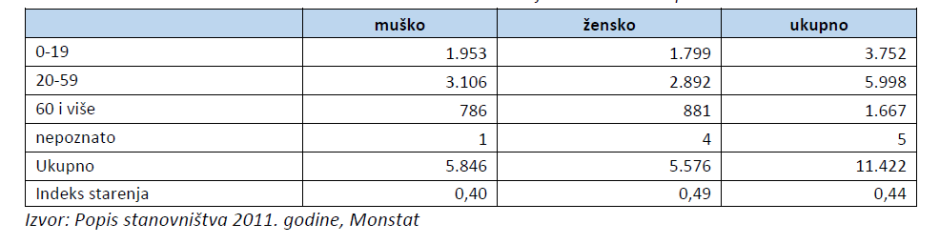
However, demographic trends indicate an aging population, depopulation especially in the hilly part of the municipality and migration. Although migration has been a problem for decades, one part should be taken with a grain of salt, both because of the change in the MONSTAT methodology and because of the administrative reasons related to re-registration since September 2018, when the town of Tuzi became a municipality.
The population density in the municipality of Tuzi is 46.3 inhabitants / km2, and at the level of Montenegro 0.8 inhabitants / km2.
The low activity and employment rate is particularly pronounced in the female population. From the total number of unemployed on June 7, 2020, the percentage of unemployed women was 54%. The activity rate in the female population is 20.7%, while in the male it is almost twice as high and amounts to 42.2%. The largest number of inactive population are housewives 28%.
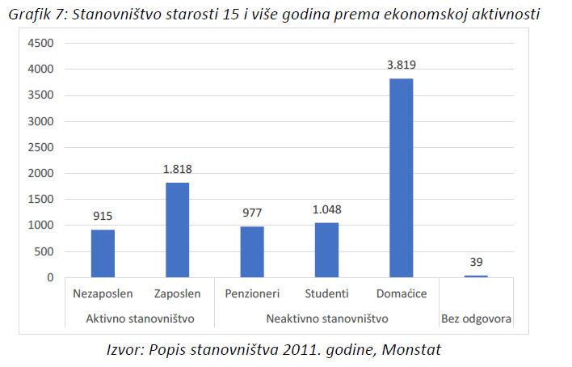
Figure 5.10 Population aged 15 and over by economic activity
The most vulnerable groups in the labor market are the low-skilled, who make up over half of the unemployed. These are mostly elderly people, over 50 years of age. Their number is increasing compared to the period from 31.12.2019 until 7.6.2020 and is more pronounced in the male population.
The service in the field of social and child protection is home help and care for persons who, due to old age, chronic illness or disability, have limited physical and mental abilities to meet their daily basic needs.
About 4,000 housing units or houses are located in this area. The largest number of households is located in the urban settlement of Tuzi, 42.2% of their total number. Their positive trend shows that the town is increasing, but also the residential property in the surrounding settlements: Vranj, Sukuruć, Omerbožovići, Donji Milješ and Gornji Milješ.
Unemployed people, pensioners, single households, people with disabilities and other recipients of social benefits are a sensitive part of the population that will be most affected by climate change because they have more difficult access to jobs, health resources, social support to cope with the negative consequences of climate change, higher energy consumption for cooling in summer, higher prices of agricultural products and milk, the impact of extreme temperatures on human health, especially the elderly population).

Expected impacts on local authorities or the region
This section presents the impacts of climate change and hazardous extreme events on lives, human health, livelihoods, ecosystems, economy, society, culture, services and infrastructure in cases where adaptation measures have not been implemented.
The sectors that are directly affected by climate change, their probability of occurrence, the expected new impact and the framework are shown in the table (Table 5.10).
Table 5.10 Expected impacts of climate change on individual sectors in the Municipality of Tuzi
Affected sector | Expected impact/s | Probability of occurrence | Expected level of impact | Time frame
Bildings | Greater need for space cooling; heat wave effect; shorter lifespan of sun-exposed elements; better thermal and waterproofing materials; damage to roofs and facades during stormy winds. | Probably | Moderate | Currently
Transport | Damage, changes in behavior and demand patterns, air quality problems, higher maintenance costs; difficult transport flow. | Possible | Moderate | Long term
Energy | Damage, changed maximum loads and demand, problem with the cooling system, interruption of electricity supply; lower electricity production due to drought; interruption in the operation of the electricity supply system during heavy rainfall / floods. | Probably | High | Short term
Water (water supply services) | With heat waves, higher demand for water, problem with water quality, higher maintenance costs, damage to infrastructure during extreme cold, water shortages during drought. | Probably | High | Short term
Waste | Half of the total waste disposal containers are worn out; waste decomposition accelerated at high temperatures and accompanied by an unpleasant odor; infrastructure damage | Probably | Moderate | Long term
Land use planning | Heat islands in the town center, land erosion, floods | Probably | High | Long-term
Agriculture and forestry | Due to the heat wave changes in the growth cycle, increased dehydration, reduced productivity in livestock, reduced milk production, hay shortage; plant death, rot, impact on yield and quality due to heavy rainfall / floods, forest health, degradation due to forest fires, Low yields per unit area. | Probably | High | Short term
Environment and biodiversity | Change of flora and fauna, new invasive species, species loss, migrations, fires. Reduced source of animal feed. | Probably | Moderate | Srednjoročni
Health | Deaths mainly due to cardiovascular diseases, altered allergic patterns, heat stress, spread of vector and infectious diseases, respiratory diseases, accumulation of microelements, spread of diseases due to polluted water, injuries and deaths during floods and storms. | Probably | Moderate | Medium term
Civil protection and emergency services | Increased number of forest fires and flood interventions | Possible | Low | Long term
Tourism | Change of the main / dead season, increase in cooling costs, increased demand for water, damage to tourist infrastructure, historical and cultural facilities, higher maintenance and repair costs. | Possible | Moderate | Short term

Starting from the analysis of previous damages from natural disasters, it is assumed that the greatest impacts will be in agriculture and forestry, due to droughts followed by heat waves, storms, heavy rains / floods. High impact is also expected in the water sector due to increased consumption in households and agriculture, in the sector of land use planning and energy. Moderate levels of impact are expected on buildings, waste management, the environment, health, tourism and transport. A low level of impact is expected in the civil protection and emergency services sector (because they are well trained and organized).

CLIMATE CHANGE MITIGATION MEASURES

- Establishment of an energy management system
Sector | Buildings - subsector of public buildings
Description of the measure | Establishment of an energy management system implies defining the boundaries of the managed system, energy policy of that system, energy manager, main and most important users, monitoring of energy consumption, as well as defining measures and priorities for implementing measures to improve energy management and energy consumption. This process of establishing an energy management system is clearly defined and described by the international standard MEST EN ISO 50001 Energy management systems - Requirements with instructions for use. The energy management system, as described in the standard can be applied to smaller systems such as one building but also wider.  Basic goals:  • Adoption of a methodology for collecting relevant energy indicators for the building sector at the municipal level  • Collection of relevant energy indicators according to the developed methodology on an annual, monthly and daily basis (depending on the type of indicators), where automatic remote reading systems will be used for collection, as well as readings by employees to further verify their accuracy;  • Development of an energy management information system at the municipal level, which will include all collected data and indicators and enable the development of all necessary analyzes;  • Preparation of the annual energy balance of the Municipality, ie. total annual energy consumption in buildings, according to Montenegrin regulations.
Responsible body / department | Municipality, energy manager, town urban planning service
Implementation timeframe – start | 2021
Implementation timeframe – end | 2030
Expected energy savings [MWh] | 5,895 MWh year 3030
Expected emission reductions CO₂ [tCO₂] | 1.455 tCO2 in 2030
Investment costs (€) | 100.000 Euros
Non-investment costs (€)
Financial resources | Municipality of Tuzi, Government of Montenegro, ECO Fund, European Bank for Reconstruction and Development

- Installation of photovoltaic panels on the roofs of public buildings
Sector | Buildings - subsector of public buildings
Description of the measure | Existing legal solutions enable very simple construction of photovoltaic systems on the roofs of buildings in terms of energy exchange at the point of connection. The administration building has significant energy consumption and high approved power. Since the building also has an auxiliary facility, as well as 3 electric meters, there is enough space to build a photovoltaic system with an installed power of 50-100 kW. Such a system could, depending on the method of implementation, cover from 50% to almost the total electricity needs on an annual basis when it comes to the administrative building. A special advantage of the construction of photovoltaic power plants on administrative buildings is the high simultaneity of electricity production with demand, which has a very favorable impact on the electricity distribution network.
Responsible body / department | Municipality, energy manager, town urban planning service
Implementation timeframe - start | 2021
Implementation timeframe - end | 2024
Expected energy savings [MWh] | 60-120 MWh in 2030
Expected emission reductions CO₂ [tCO₂] | 20-41 tCO2 in 2030
Investment costs (€) | 50.000 - 90.000 Euros
Non-nvestment costs (€)
Financial resources | Municipality budget  ECO Fund  European Bank for Reconstruction and Development

- Installation of photovoltaic panels on school roofs
Sector | Buildings - subsector of public buildings
Description of the measure | Existing legal solutions enable very simple construction of photovoltaic systems on the roofs of buildings in terms of energy exchange at the point of connection. There are 12 school buildings in the Municipality of Tuzi and each of them (roof) can be a potential location for the construction of small photovoltaic power plants with a capacity of at least 30 kW per building. Where conditions allow, that power can be even higher. Taking into account the number of facilities, the total installed power of photovoltaic power plants would be between 360 kW and 500 kW. A special advantage of the construction of photovoltaic power plants on school buildings is the high simultaneity of electricity production with demand, which has a very favorable impact on the electricity distribution network. Such a system could, depending on the method of implementation, cover from 50% to almost the total electricity needs on an annual basis when it comes to schools.
Responsible body / department | Municipality, relevant ministry
Implementation timeframe - start | 2021
Implementation timeframe - end | 2025
Expected energy savings [MWh] | 432-600 MWh in 2030
Expected emission reductions CO₂ [tCO₂] | 147-204 tCO2 in 2030
Investment costs (€) | 330.000 - 450.000 Euros
Non-nvestment costs (€)
Financial resources | ECO fund  European Bank for Reconstruction and Development  Relevant ministry

- Reconstruction of facades and facade carpentry on buildings of the commercial and service sector
Sector | Buildings - subsector of commercial building
Description of the measure | This measure is recognized as a very effective measure for achieving savings in energy consumption, primarily for the needs of air conditioning. Problems that service and commercial sector buildings have due to poor thermal insulation have been identified. Facilities that are candidates for the implementation of this measure must have a prior energy audit in order to give priority to those facilities that have the highest energy losses. The measure would be limited to 4% of facilities per year (observed as a share in the total area of ​​facilities in the commercial and service sectors). This would achieve the result that 30% of buildings in 2030 have improved thermal insulation characteristics by at least 40% compared to the existing condition.
Responsible body / department | Municipality, relevant ministry
Implementation timeframe - start | 2021
Implementation timeframe - end | 2030
Expected energy savings [MWh] | 1340 MWh in 2030
Expected emission reductions CO₂ [tCO₂] | 456 tCO2 in 2030
Investment costs (€) | 9.000.000 Euros
Non-nvestment costs (€)
Financial resources | Own funds of building owners  ECO fund  EU funds and programs  Programs of competent ministries  European Bank for Reconstruction and Development

- Raising citizens' awareness of energy efficiency and renewable energy sources (RES)
Sector | Buildings - residential building subsector
Description of the measure | The measure includes a number of educational activities that are regularly carried out:  • opening of EE info-corners in key town positions  • continuous informing consumers about ways to save energy  • conducting thematic information campaigns to raise awareness of energy efficiency and RES  • organization of meetings and campaigns on the design, construction and use of buildings in a sustainable way for target groups  • production of leaflets and promotional materials on energy efficiency and RES  • organization of the Town Energy Days at least once a year  • support to citizens in projects to increase energy efficiency and the use of RES.  It is estimated that the implementation of this measure would achieve savings of at least 15% by 2030 in the residential sector.
Responsible body / department | Municipality, relevant ministry
Implementation timeframe - start | 2021
Implementation timeframe - end | 2024
Expected energy savings [MWh] | 7.032 MWh in 2030
Expected emission reductions CO₂ [tCO₂] | 1.570 tCO2 in 2030
Investment costs (€) | 40.000 Euros
Non-nvestment costs (€)
Financial resources | Municipality budget  ECO Fund  EU funds and programmes  Programmes of relvant ministries  European Bank for Reconstruction and Development

- Installation of photovoltaic panels on the roofs of family houses
Sector | Buildings - residential building subsector
Description of the measure | Existing legal solutions enable very simple construction of photovoltaic systems on the roofs of buildings in terms of energy exchange at the point of connection. The procedures are especially simplified for households that intend to install photovoltaic systems up to 10 kW of installed power. Systems with an installed power of 5-6 kW are sufficient to fully meet the needs of the average household for electricity on an annual basis.  The total number of residential buildings in the reference year is 1,572. This measure assumes the construction of photovoltaic systems with an installed capacity of 6 kW on 40% of facilities from the reference year until 2030, which makes the total installed capacity of distributed photovoltaic power plants of close to 3.8 MW in 2030.
Responsible body / department | Municipality, energy manager, town urban planning service
Implementation timeframe - start | 2021
Implementation timeframe - end | 2030
Expected energy savings [MWh] | 4.527 MWh in 2030
Expected emission reductions CO₂ [tCO₂] | 1,539 tCO2 in 2030
Investment costs (€) | 4.000.000 E
Non-investment costs (€)
Financial resources | Own funds of building owners  Municipal budget  ECO fund  European Bank for Reconstruction and Development

- Renovation of thermal insulation and heating system of family houses
Sector | Buildings - residential building subsector
Description of the measure | The measure includes the reconstruction of the thermal insulation of the outer shell of the building and the repair of the roof and carpentry, as well as the replacement of the heating system of family houses in the administrative area of ​​the town. This measure primarily refers to buildings that have large energy losses caused by poor thermal insulation and inefficient heating systems. Assuming that 4% of the buildings in the housing sector will be renovated annually (participation in the total useful area of ​​this sector is observed), which means that approximately 630 family houses will be included in the reconstruction by 2030. It is estimated that with this measure it is possible to achieve energy savings of about 60 kWh / m² with investment costs of 200 EUR/m².
Responsible body / department | Municipality, energy manager, town urban planning service
Implementation timeframe - start | 2021
Implementation timeframe - end | 2030
Expected energy savings [MWh] | 8.013 MWh in 2030
Expected emission reductions CO₂ [tCO₂] | 1.789 tCO2 in 2030
Investment costs (€) | 26.700.000 Euros
Non-nvestment costs (€)
Financial resources | Homeowners' own funds  Municipal budget  ECO fund  European Bank for Reconstruction and Development

- Replacing worn-out Na lamps with LED lamps
Sector | Public lighting
Description of the measure | This measure plans to completely replace the world's public lighting of traditional production with LED public lighting. Part of public lighting (20%) already makes LED lighting. The first phase of the replacement includes 1,000 global and planned liabilities by 2025, and the remaining 1,800 global liabilities by 2027. Currently, public lighting is dominated by lamps with a sodium light source (power 70 V, 100 V, 150 V and 250 V). In addition to savings in energy consumption and CO2 emissions, this measure achieves and reduces maintenance costs, increases average lighting and improves the quality of life of the local population.
Responsible body / department | Municipality, energy manager, town urban planning service
Implementation timeframe - start | 2021
Implementation timeframe - end | 2030
Expected energy savings [MWh] | 900 MWh in 2030
Expected emission reductions CO₂ [tCO₂] | 306 tCO2 in 2030
Investment costs (€) | 700.000 Euros
Non-nvestment costs (€)
Financial resources | Municipal budget  ECO fund  European Bank for Reconstruction and Development

- Development of infrastructure for alternative fuel vehicles
Sector | Transport
Description of the measure | The aim of this measure is to facilitate the acceptance of alternative fuels by users / consumers by strengthening the infrastructure for the distribution of alternative fuels. First of all, these are stations for electric vehicles.  There are about ten stations in Montenegro, and so many more are in the process of being designed. There are several programs that subsidize the construction of charging stations for electric vehicles. There are 2 types of stations: fast (above 22 kW) and slow (up to 22 kW). In the initial phase of infrastructure development for electric vehicles, slow charging stations are in the foreground. According to studies that project an increase in the number of vehicles, by 2030 the share of electric vehicles in the total number of vehicles is expected to be 5%, which is 183 vehicles for the Municipality of Tuzi compared to the reference year. If subsidies for the purchase of electric vehicles are taken into account, it is possible to reach projections of an optimistic scenario corresponding to a share of 10% of vehicles. According to the EU Directive 2014/94 / EU on the establishment of infrastructure for alternative fuels, at least one charging station should be installed on 10 electric cars. Among them, 4 fast and 32 slow should be chosen.
Responsible body / department | Municipality, energy manager, town urban planning service
Implementation timeframe - start | 2021
Implementation timeframe - end | 2030
Expected energy savings [MWh] | 1.955 MWh in 2030
Expected emission reductions CO₂ [tCO₂] | 470 tCO2 in 2030
Investment costs (€) | 3.230.000 Euros
Non-nvestment costs (€)
Financial resources | Municipal budget  ECO fund  European Bank for Reconstruction and Development

- Electrification of the railway Podgorica - Tuzi - Border with Albania
Sector | Transport
Description of the measure | The Strategic Plan of the Municipality of Tuzi defines as one of the strategic goals Strategic Goal 2: Improved communal infrastructure, transport and environmental protection, which has Priority 2.4 Construction and Reconstruction of Road and Railway Infrastructure. The construction of the railway infrastructure, ie its electrification, would have the effect of substituting bus transport, but also alleviating the need for new passenger vehicles and freight transport. As the new mode of transport of passengers and goods has a direct consequence of the substitution of currently predominantly used diesel fuel, it is clear that this will have a very favorable impact on the level of emissions, after the completion of this project.  It is envisaged that the project has 3 phases: of which the most significant activities include:  - Phase II - EUR 2,100,000  - Phase III - EUR 35,100,000.  Taking into account the volume of public passenger transport in the reference year, but also the existing number of passenger vehicles and typical conditions of use, it is possible to make an estimate of the energy savings that can be expected. It should be emphasized that the studies that follow the development of the project will offer additional data for the evaluation of the expected effects of this project in terms of the impact on the energy balance of the municipality, ie the level of reduction of CO2 emissions.  For the purposes of this plan, a complete substitution of bus transport (64,000 passengers per year) is assumed, as well as a reduction of 5% in the number of vehicles in the horizon of the plan year.
Responsible body / department | Municipality, energy manager, town urban planning service
Implementation timeframe - start | 2021
Implementation timeframe - end | 2029
Expected energy savings [MWh] | 1.925 MWh in 2030
Expected emission reductions CO₂ [tCO₂] | 521 tCO2 in 2030
Investment costs (€) | 37.200.000 Euros
Non-nvestment costs (€)
Financial resources | Municipal budget  ECO fund  European Bank for Reconstruction and Development

11. Feasibility study of construction and construction of photovoltaic and wind power plants on the territory of the Municipality
Sector | Development measure
Description of the measure | The municipality of Tuzi has significant potential for local use of solar and wind energy. In that sense, research was previously conducted and 3 locations were identified:  1) LSL Tuzi 1 solar power plant (KO HOTI - Drume) of 159,652 m²,  2) LSL Tuzi 2 solar power plant (KO HOTI - Drume) of 413,726 m²  3) LSL Stijepovo - Budza (KO ZATRIJEBAČ - Budza) - wind farm on the territory of 3,709,763 m²  Preliminary analyzes indicate the potential for the construction of 2 photovoltaic power plants with an installed capacity of 20 and 50 MW, or wind power plants between 20 and 50 MW. However, it is necessary to prepare a detailed feasibility study in order to take into account all aspects of interest, such as guaranteed energy placement, connectivity and construction dynamics that are in line with the spatial planning documentation.  The construction of these renewable energy sources would fully meet the needs for electricity in the Municipality of Tuzi. Of course, this can only be pointed out in terms of total annual production and electricity consumption. However, due to the unequal production from these sources and the needs of consumers in the municipality, it is clear that a significant part of the needs will be taken over from the public electricity supplier. In this regard, it is not possible to count on a complete substitution of electricity taken from the public network with that produced from the mentioned renewable energy sources, but only a partial substitution in a conservatively estimated amount of 15% of total annual production will be counted here.
Responsible body / department | Municipality, energy manager, town urban planning service
Implementation timeframe - start | 2021
Implementation timeframe - end | 2026
Expected energy savings [MWh] | 144,000 MWh (construction of 70 MW photovoltaic power plants and 20 MW wind farms is assumed)
Expected emission reductions CO₂ [tCO₂] | 7.344 tCO₂
Investment costs (€) | 40,000 Euros (feasibility study) + 90,000,000 Euros (construction)
Non-nvestment costs (€)
Financial resources | Municipal budget  ECO fund  European Bank for Reconstruction and Development

MEASURES TO ADAPT TO CLIMATE CHANGE
- Increasing the energy efficiency of buildings
Sector | Buildings
Description of the measure | Application of light colors of facades and reflective coating on the facades of existing and future buildings, including thermal insulation and waterproofing protection. This would increase the efficiency of buildings because it would reduce their heating in summer (due to the reflection of solar radiation) and form a more favorable microclimate of the urban zone; it would reduce energy consumption and increase the resistance to wetting of walls during intense rainfall followed by storms.
Responsible body / department | Apartment owners, town urban planning service
Implementation timeframe - start | 2021
Implementation timeframe - end | 2030
Action affects mitigation | Yes
Risk and / or vulnerabilities | Heat and cold waves, heavy rains
Achieved results | Better microclimate in the urban zone, reduced energy consumption, reduction of atmospheric moisture from rain or snow, prevention of water penetration into foundations and basements.
Implementation status | -
Investment costs (€) | 400.000 Euros
Non-investment costs (€)
Financial resources | Municipality of Tuzi,  Government of Montenegro, PPP (get involved in the work of the Public-Private Partnership Network in Southeast Europe)  European Bank for Reconstruction and Development

- Regulation of torrents
Sector | Water
Description of the measure | Regulation of the Rujela riverbed from the source in Milješ to the inflow into Skadar Lake with the aim of preventing its overflow at high waters. In this way, the flooding of the agricultural area and facilities during heavy rains is solved, the atmospheric sewage of the center of Tuzi, which is connected to the river Rujela, is relieved, the ambience is preserved, recreational activities are improved (hiking trail 1,500 m).
Responsible body / department | Municipality of Tuzi
Implementation timeframe - start
Implementation timeframe - end | 2026
Action affects mitigation | No
Risk and / or vulnerabilities | Reducing the risk or vulnerability to heavy rains leading to flooding
Achieved results | Monitoring of irrigation of individual crops
Implementation status
Investment costs (€) | 5.601.000 Euros
Non-investment costs (€)
Financial resources | Municipality of Tuzi, Government of Montenegro, International Funds

- Development of a cadastre of existing and potential sources (water bodies)
Sector | Water
Description of the measure | Identification of all sources and their protection against pollution. Research of water quality status, real and potential pollution, pollution sources, protection measures and establishment of information system on water and water resources management.
Responsible body / department | Municipality of Tuzi
Implementation timeframe - start
Implementation timeframe - end | 2024
Action affects mitigation | No
Risk and / or vulnerabilities | Heavy rainfall leading to flooding
Achieved results | Better quality of life, increasing environmental standards
Implementation status
Investment costs (€) | 30.000 Euros
Non-investment costs (€)
Financial resources | Municipality of Tuzi, Ministry of Agriculture, Forestry and Water Management, Komunalno doo

- Water supply of settlements in the hilly area
Sector | Water
Description of the measure | Development of a project for the construction of a water supply network in order to provide drinking water to the population living in the mountainous area.
Responsible body / department | Municipality of Tuzi
Implementation timeframe - start
Implementation timeframe - end | 2021
Action affects mitigation | No
Risk and / or vulnerabilities | Drought followed by heat waves
Achieved results | The project documentation has been prepared and the conditions for its implementation have been created.
Implementation status | -
Investment costs (€) | 68.000 Euros
Non-investment costs (€)
Financial resources | Municipality of Tuzi

5. Information and education of farmers
Sector | Agriculture and forestry
Description of the measure | Informing and educating farmers about the importance and application of a well-developed early warning system for hydrometeorological hazards, about the impact of climate change on farming, fruit growing and animal husbandry. Presentation of new crop species resistant to future climate and invasive weed species. Planting trees to reduce high exposure to sunlight. Exchange of knowledge and experiences with other farmers.
Responsible body / department | Municipality of Tuzi
Implementation timeframe - start
Implementation timeframe - end | 2022
Action affects mitigation | No
Risk and / or vulnerabilities | Drought followed by heat waves, open fires, stormy winds and heavy rainfall leading to floods
Achieved results | Application of new knowledge
Implementation status
Investment costs (€) | 8.000 Euros
Non-investment costs (€) | 1.500 Euros
Financial resources | Municipality of Tuzi, Ministry of Agriculture, Forestry and Water Management

6. Afforestation of neglected and degraded forest areas
Sector | Agriculture and forestry
Description of the measure | Afforestation of forest areas that are degraded and neglected by planting indigenous species in order to prevent the spread of easily flammable low vegetation
Responsible body / department | Municipality of Tuzi
Implementation timeframe - start
Implementation timeframe - end | 2024
Action affects mitigation | Yes
Risk and / or vulnerabilities | Droughts followed by heat waves and forest fires
Achieved results | Degraded areas are forested, reduced exposure to solar radiation, reduced soil erosion
Implementation status
Investment costs (€) | 30.000 Euros
Non-investment costs (€)
Financial resources | Municipality of Tuzi, Ministry of Agriculture, Forestry and Water Management, Utility Company

7. Preparation of the cadastre of agricultural areas
Sector | Agriculture and forestry
Description of the measure | Development of agricultural land cadastre and management plan. This will provide insight into the area of ​​arable land and the species grown on it, suggesting to farmers to make changes in their production plans, especially for vegetable growing, taking into account climate change.
Responsible body / department | Municipality of Tuzi
Implementation timeframe - start | 2022
Implementation timeframe - end | 2026
Action affects mitigation | No
Risk and / or vulnerabilities | Droughts followed by heat waves, stormy winds, heavy rains that lead to floods
Achieved results | Cadastre of agricultural areas
Implementation status
Investment costs (€) | 40.000 Euros
Non-investment costs (€)
Financial resources | Municipality of Tuzi, Ministry of Agriculture, Forestry and Water Management, International Organizations.

8. Information and education on waste reduction
Sector | Waste management
Description of the measure | Conducting education and public information on waste reduction, especially in educational institutions. The goal is to acquire the habit of reducing and properly disposing of waste and passing on such habits to their parents.
Responsible body / department | Municipality of Tuzi
Implementation timeframe - start | 2021
Implementation timeframe - end | 2024
Action affects mitigation | Yes
Risk and / or vulnerabilities | Stormy winds, heavy rains
Achieved results | The education was conducted in educational institutions and the application of new habits began in it.
Implementation status
Investment costs (€) | Include in measures to reduce CO₂ emissions
Non-investment costs (€)
Financial resources | Municipality of Tuzi, Ministry of Agriculture, Forestry and Water Management, IPA funds for cross-border interregional cooperation

9. Land conversion along watercourses
Sector | Land use planning
Description of the measure | Land conversion along watercourses in order to reduce flooding of buildings. Landscaping for recreation (bike paths, playgrounds)
Responsible body / department | Municipality of Tuzi
Implementation timeframe - start | 2022
Implementation timeframe - end | 2030
Action affects mitigation | No
Risk and / or vulnerabilities | Heavy rains leading to flooding
Achieved results | The land has been arranged into retentions, bicycle paths and playgrounds have been built
Implementation status
Investment costs (€) | 200.000 Euros
Non-investment costs (€)
Financial resources | Ministry of Agriculture, Forestry and Water Management, IPA funds for cross-border, interregional cooperation

10. Maintenance of public green areas
Sector | Environment and biodiversity
Description of the measure | Sustainable management of public green areas in order to green and beautify the town. Introduction of types of greenery that are resistant to extreme weather and climatic events. In that way, greater absorption of gases, reduction of noise, increase of air humidity and microclimate of the town will be achieved.
Responsible body / department | d.o.o “Komunalno/Komunale“ Tuzi
Implementation timeframe - start | 2021
Implementation timeframe - end | 2022
Action affects mitigation | Yes
Risk and / or vulnerabilities | Heat waves
Achieved results | Landscaped green areas
Implementation status
Investment costs (€) | 15.000 Euros
Non-investment costs (€)
Financial resources | Municipality of Tuzi, d.o.o. "Komunalno / Komunale" Tuzi

11. Biodiversity protection in the area of ​​Natural Monument “Cijevna Canyon”
Sector | Environment and biodiversity
Description of the measure | Protection of endemic flora and fauna, determination of locations for special activities. Determining the area of ​​space occupied by a plant community. Examining the impact of climate change on biodiversity. It is necessary to make a Management Plan and a Special Purpose Plan, as well as to form a body for the management of the Natural Monument Cijevna Canyon
Responsible body / department | Municipality of Tuzi
Implementation timeframe - start | 2021
Implementation timeframe - end | 2024
Action affects mitigation | N0
Risk and / or vulnerabilities | Drought followed by heat waves
Achieved results | Marked external and internal border, plant species fencing and its valorization based on sustainable development
Implementation status | Municipality of Tuzi 2021 2024 Not 10,000 Euros Tuzi
Investment costs (€) | 10.000 Euros
Non-investment costs (€)
Financial resources | Municipality of Tuzi, Ministry of Science and Education, Ministry of Agriculture, Forestry and Water Management, International organizations

12. Establishment of Tuzi emergency medical care
Sector | Health
Description of the measure | Establishment of an organizational unit for emergency medical care in the municipality of Tuzi in order to improve emergency medical care services.
Responsible body / department | Municipality of Tuzi, Government of Montenegro, Ministry of Health
Implementation timeframe - start | 2021
Implementation timeframe - end | 2026
Action affects mitigation | No
Risk and / or vulnerabilities | Heat waves accompanied by extreme temperatures, heavy rains, floods, storms
Achieved results | Emergency medical care has been established in the municipality of Tuzi
Implementation status
Investment costs (€) | The value of the required funds will be determined later after consultations with the Ministry of Health.
Non-investment costs (€)
Financial resources | Government of Montenegro, Ministry of Health

13. Improving health care in the Tuzi Health Center
Sector | Health
Description of the measure | Initiating the establishment of new health services within the health facility in Tuzi.
Responsible body / department | Municipality of Tuzi, Government of Montenegro, Ministry of Health
Implementation timeframe - start | 2021
Implementation timeframe - end | 2026
Action affects mitigation | No
Risk and / or vulnerabilities | Heat waves accompanied by high temperatures, heavy rains, floods, storms
Achieved results | New health services and diagnostic devices introduced
Implementation status
Investment costs (€) | The value of the required funds will be determined later after consultations with the Ministry of Health
Non-investment costs (€)
Financial resources | Government of Montenegro, Ministry of Health

Table 7.1 Summary of climate change adaptation measures
 | Sector | The measure title | The cost of the measure €
1 | Buildings | Increasing the energy efficiency of buildings | 400.000
2 | Water | Regulation of torrents | 5.601.000
3 | Water | Development of a cadastre of existing and potential sources (water objects) | 30.000
4 | Water | Water supply of settlements in the hilly area | 68.000
5 | Agriculture and forestry | Information and education of farmers | 8.000
6 | Agriculture and forestry | Afforestation of neglected and degraded forest areas | 30.000
7 | Agriculture and forestry | Preparation of the cadastre of agricultural areas | 40.000
8 | Waste | Information and education on waste reduction | Include in measures to reduce CO2 emission
9 | Land use planning | Land conversion along watercourses | 200.000
10 | Environment and biodiversity | Maintenance of public green areas | 15.000
11 | Environment and biodiversity | Biodiversity protection in the area of ​​the Natural Monument “Cijevna Canyon” | 10.000
12 | Health | Establishment of Tuzi emergency medical care | The value of the required funds will be determined later after consultations with the Ministry of Healths
13 | Health | Improving health care in the Tuzi Health Center | The value of the required funds will be determined later after consultations with the Ministry of Healths
 | Total |  | 6.402.000

ASSESSMENT OF THE EFFECTS OF CLIMATE CHANGE MITIGATION MEASURES
For the purpose of estimating the reduction of CO2 emissions by 2030, projections of energy consumption and CO2 emissions by 2030 were made for two scenarios, without measures (BAU) and with measures (MIT). The basic scenario that represents a change in energy consumption depending on market trends and consumer habits is the scenario without measures. The scenario without measures is presented with the assumption of the usual application of new, technologically advanced products that appear on the market over time, but without the systematic implementation of energy efficiency measures.

Buildings
An overview of the results of energy consumption projections for the two analyzed scenarios will be given below (Table 8.1 and Table 8.2). It can be noticed that the selected measures give the greatest effect in reducing the energy intensity of the building sector, namely the residential subsector, where the reduction of energy consumption is approximately 42%. It is important to point out the subsector of commercial buildings with a reduction of energy consumption of 23% due to its importance in the overall energy balance.
Table 8.1 Energy consumption in the building sector in 2030 [MWh]
 | Without measures | With measures
Residetial buildings | 46.878,09 | 27.145,57
Public buildings | 1.776,71 | 1.599,03
Commercial buildings | 10.297,84 | 7.927,97
Total buildings | 58.952,63 | 36.672,57

When it comes to CO₂ emissions, the effect of measures in the residential sector is even more noticeable because the reduction of CO2 emissions is as much as 91%. It should be noted here that the greatest effect was the significant use of local potential for electricity production from renewable energy sources, which practically fully met the needs for electricity that were met in the baseline scenario by the public supplier (which sells a significant part of electricity annually from the thermal power plant ). Also, an important impact on reducing emissions has a reduction in the consumption of all types of energy, which is the result of measures to improve energy efficiency. It should be emphasized here that the improvement of the production mix at the state level is to be expected, in the form of a larger share of RES, and this can only improve the result obtained by the proposed measures.
Table 8.2 CO₂ emissions in the building sector in 2030 [tCO₂]
 | Without measures | With measures
Residetial buildings | 10.467,14 | 242,38
Public buildings | 585,78 | 103,78
Commercial buildings | 3.501,27 | 926,17
Total buildings | 14.554,19 | 1.272,33

It should be emphasized that measures in the building sector are scalable and can be increased in intensity if resources are available both in terms of finances and professional capacity.

Public lighting
The only measure that treats public lighting has significantly reduced energy consumption because it has replaced the old and poorly efficient technology (sodium light sources) with a modern energy efficient solution in the form of LED lamps. Lamp replacement is done in 2 phases for easier implementation (Table 8.3 and Table 8.4). It is important to emphasize that by using the recognized local potential of renewable energy sources in the horizon of the year, a complete substitution of electricity taken from the public electricity supply system is achieved, which completely eliminates the contribution to CO₂ emissions.
Table 8.3 Energy consumption in the public lighting sector in 2030 [MWh]
 | Without measures | With measures
Pubic lighting | 1.400 | 500

Tabela 8.4 Emission CO₂ in the public lighting sector in 2030 [tCO₂]
 | Without measures | With measures
Pubic lighting | 476 | 0

Transport
The transport sector, along with the building sector, is characterized by the most intensive energy consumption, and especially by the impact on the level of CO2 emissions. A particularly unfavorable circumstance is the extremely dominant impact of urban transport on the overall energy consumption of the sector. This circumstance directs planners to define measures for this subsector. The only long-term solution here is fuel substitution (diesel in the first place) with environmentally friendly alternatives in the form of biofuels or electricity. The placement of biofuels on the Montenegrin market is planned by the first Energy Development Strategy, but to date it has not moved from the starting position, so the only alternative is the introduction of electromobility through the construction of infrastructure and facilities for the purchase and use of electric vehicles. However, the current trend in Montenegro is such that no significant growth in the number of electric vehicles is expected, so an optimistic recommendation from the Electromobility Study in Montenegro was adopted as a measure, which is that by 2030 10% of registered cars will be electric cars. It should be added that the implementation of the already planned project for the construction of railway infrastructure, which is recognized as an alternative to existing public transport (bus and taxi) with some impact on limiting the growth of passenger cars compared to the baseline scenario that does not provide for railway infrastructure. This gave a modest effect in the form of a reduction in energy consumption of 9% and emissions of 12% (Table 8.5 and Table 8.6).
Table 8.5 Energy consumption in the transport sector in 2030 [MWh]
 | Without measures | With measures
Town administration vehicles | 119,22 | 119,22
Public transport | 748,23 | 65,69
Town road transport | 40.850,50 | 37.587,34
Total Transport | 41.717,96 | 37.772,25

Table 8.6 CO₂ emissions in the transport sector in 2030 [tCO₂]
 | Without measures | With measures
Town administration vehicles | 31,83 | 31,83
Public transport | 199,78 | 17,54
Town Road Transport | 10.833,78 | 9.736,44
Total Transport | 11.065,39 | 9.785,81

Overall overview
Summarizing all the results by sectors, a general overview of energy consumption by scenarios with accompanying CO₂ emissions is obtained (Table 8.7 and Table 8.8).
Table 8.7 Total energy consumption by sectors in 2030 [MWh]
 | Without measures | With measures
Building construction | 58.952,63 | 36.672,57
Public lighting | 1.400 | 500
Transport | 41.717,96 | 37.772,25
Total | 102.070,59 | 74.944,82

Total energy consumption decreased by approximately 27% compared to the scenario without measures, mostly due to the strong effect of measures in the building sector, which is expected because this sector is dominant in terms of energy consumption. Also, the effect of the measures is especially noticeable when it comes to CO₂ emissions (use of local potential of renewable energy sources and energy efficiency measures), where after the implementation of measures the building sector is no longer the most intensive in terms of emissions of approximately 58% in the year horizon compared to the scenario without measures.
Table 8.8 Total CO2 emissions by sectors in 2030 [tCO₂]
 | Without measures | With measures
Building construction | 14.554,19 | 1.272,33
Public lighting | 476 | 0
Transport | 11.065,39 | 9.785,81
Total | 26.095,58 | 11.058,14

An overview of the individual effects of the selected measures is given in the following graph.
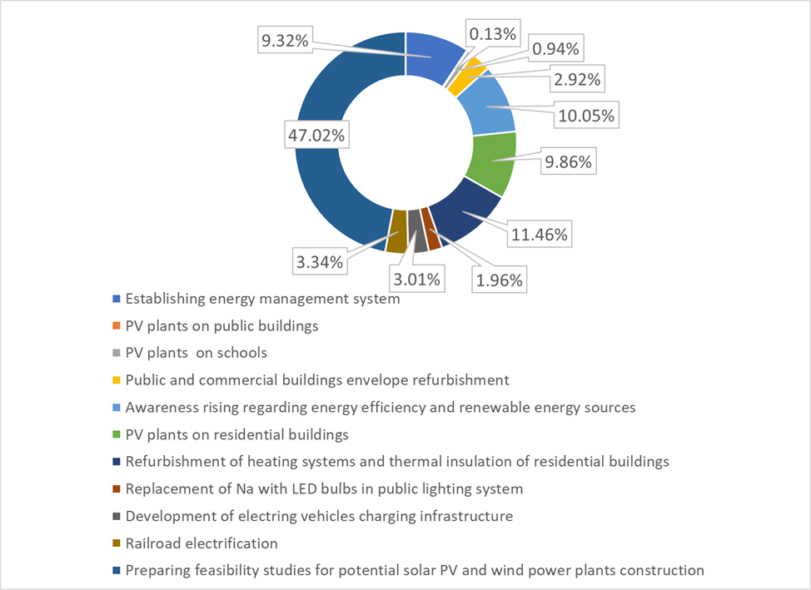
Figure 8.1 Overview of the effects of measures
It is especially important to emphasize that the selected measures enable the achievement of the set goal of 40% reduction of CO₂ emissions compared to the reference year (2019), and up to the horizon of the year (2030). The effect of measures by years is given in the figure below (Figure 8.2). The figure shows the basic scenario of increasing CO₂emissions that follows the current trend (without the application of climate change mitigation measures), as well as the scenario with measures (MIT).
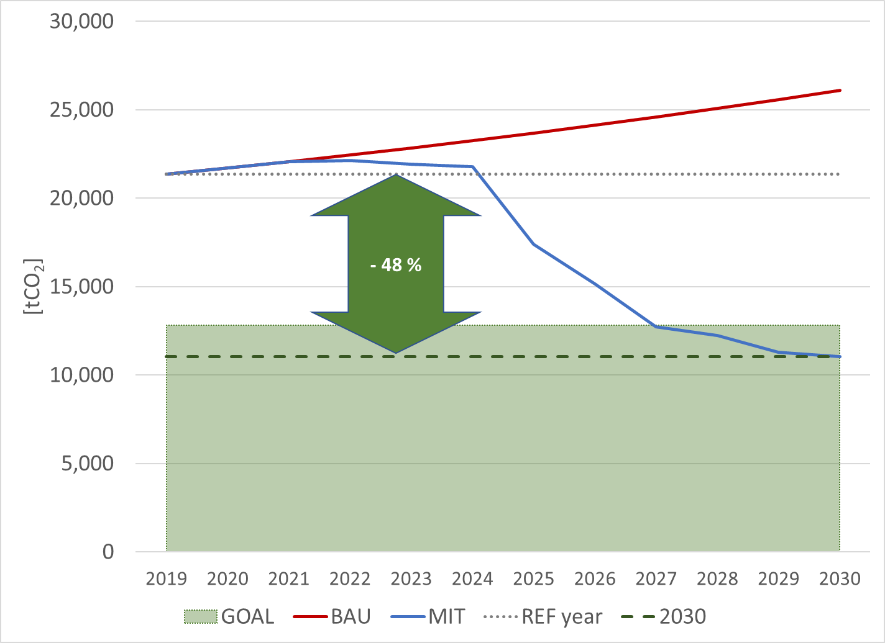
Figure 8.2 Comparison of scenarios with measures (MIT) versus baseline (BAU) with reference year and target
It can be seen (Figure 8.2) that more serious effects of mitigation measures are expected from 2025, primarily due to the need to prepare projects and provide funding, especially when it comes to projects with the greatest effects (use of significant local potential for electricity production from renewable energy sources). Also, it can be noticed that the set goal is achieved earlier than the horizon of the year, ie. 2027, and to achieve a reduction of emissions of 48% in relation to the reference year in the horizon of the year. It should be emphasized that the effects can be better, either in terms of emission reduction levels or the dynamics of achieving the target, because the measures applied at the municipal level have a direct impact on the results at the municipal level, primarily in the form of improving the production mix on the effect of using electricity at the municipal level as the dominant energy source. Also, a special focus of emissions remains the transport sector, and when updating this document or in the next planning period, it is necessary to find additional measures to further improve the result achieved in this sector.

IMPLEMENTATION OF THE ACTION PLAN
For the successful implementation of the Action Plan, a number of measures will be taken, which can be grouped into the following units:
• Organization of implementation
• Implementation monitoring and reporting
• Structural adjustment.

Organization of implementation
The implementation of the program will be entrusted to the program coordinator. The program coordinator is in charge of the operational implementation of measures. The operational implementation of the measures will include administrative bodies and town institutions and companies, whose representatives will be in charge of the sectors in accordance with their competencies. The program coordinator is an employee, whose role is related to energy issues, but he also has a good overview of the functioning of local government and knowledge and skills on project management.
The Committee for Monitoring the Implementation of the Action Plan makes strategic decisions, including the plan for the implementation of activities in certain measures (usually decisions on capital investments, priorities, method of financing, etc.) and communicates with other participants outside public administration.
The industrial sector is not covered by this Action Plan, because there are no industrial capacities in the municipality.
The working groups for the implementation of the Action Plan are composed of experts for certain sectors, but also other employees of the municipality, whose role is important in the process of project implementation. These are usually representatives of the administrative bodies of the municipality of Tuzi. For each of the measures from the Action Plan, if necessary, representatives of public institutions and companies will be included in the working groups.

Implementation monitoring and reporting
The adoption of the Action Plan marks the beginning of a new challenging period full of challenges. This Action Plan, together with the Basic Inventory of CO2 Emissions (BEI), is the starting point against which to measure the progress of the town of Tuzi in its efforts to become a "green town". Each proposed measure will contribute to the reduction of CO2 emissions. However, in order for the town of Tuzi to have an insight into the success of the implementation of each of the measures and early and rapid adjustment of each of the measures (eg implementation of measures is late, the actual effect of measures differs from expected, etc.), it is necessary to define and apply monitoring the implementation of the Action Plan. The envisaged measures include the aspect of coordination, reporting and support systems.

Coordination
In its day-to-day work, the program coordinator will coordinate the work of several working groups in charge of each sector. The need for coordination will arise in the processes of planning, operationalization, monitoring and adjustment of each of the measures in the Action Plan. Some measures will require the permanent involvement of town structures, while some measures will have the character of a project and will have a limited duration. Since each measure will, as a rule, cover almost the entire organizational structure of the municipality of Tuzi, this job will be very challenging.
In addition to the working groups, the program coordinator will have to cooperate intensively with the committee for monitoring the implementation of the Action Plan.

Reporting
After the local parliament of the Municipality of Tuzi adopts the Action Plan and after the Action Plan is sent to the Secretariat of the Covenant of Mayors for Energy and Climate, the implementation of the Action Plan will begin.
By signing the Covenant of Mayors for Energy and Climate, the Municipality of Tuzi has committed to submit a report to the Secretariat of the Covenant of Mayors (CoM) every two years.

Support
Support mainly means information systems, whose task is to facilitate coordination and decision-making during the implementation of the Action Plan.
Due to the potentially larger number of participants involved in the implementation of the Action Plan, it will be necessary to use the existing or try to introduce an IT system that will facilitate, accelerate and structure the flow of information and documents among members of working groups involved in the implementation of the Action Plan.
The process of monitoring the implementation of the Action Plan will require in the initial phase the processing and storage of data collected in the process of its development.
In the implementation phase, there will be a need to collect a significant amount of data and process it, as well as to expand the available data sources. To facilitate handling, monitoring, reporting and decision making, data needs to be carefully processed, stored and prepared for presentation.

Structural adjustment
The Municipality of Tuzi is organized through administrative bodies and town institutions and companies. Given the diversity of areas of activity, organizations and services they provide, and taking into account the fact that each of the organizational units should be directly or indirectly involved in the implementation of this Action Plan, activities and adjustments will be undertaken, which will result in its successful implementation.
Based on the proposed set of measures, the relevant organizational units that will participate in the implementation of the Action Plan will be identified. In the short term, activities will be undertaken that will not require any changes in the organizational structure of local government and town institutions and companies. In the long run, there may be a need for alignment, which will require capacity building. The implementation of the Action Plan will require occasional intensive involvement of employees, so the Municipality will have to temporarily reallocate resources to projects as part of the implementation of the Action Plan.
For each of the organizational units that will participate in the implementation of the Action Plan, it will be necessary to consider a new definition of roles that will include activities on implementation activities.
If necessary, in organizational units in which the implementation of the Action Plan will initiate new activities, include more employees and greater engagement, it will be necessary to consider the introduction of a new job or a new job description that will include activities under the organizational unit. This decision does not imply the need to create a new job, but to harmonize existing resources and redistribute responsibilities among employees.
The structure and job descriptions of employees, when it comes to processes within the local government or processes involving town institutions and companies, will need to be thoroughly checked and changed if necessary, in order to facilitate the flow of information, reduce decision-making time and increase overall "Visibility" of the implementation of programs or measures. Processes will be constantly reviewed as it is expected that over time there will be changes that will to a greater or lesser extent affect the implementation of the Action Plan. The Program Coordinator for the implementation of the Action Plan must initiate changes.

PROVIDING RESOURCES FOR IMPLEMENTATION OF THE ACTION PLAN

Human resources
According to the number, scope and complexity of the proposed measures to reduce CO2 emissions, it is envisaged that for the implementation of the Action Plan it is necessary to spend full-time work corresponding to the full-time work of one employee. It is recommended that the program coordinator be at the same time the energy manager, which is an obligation in accordance with the Law on Efficient Use of Energy.

Sources of funding
The implementation of the proposed measures may require significant investments. Montenegro has opportunities to withdraw funds from various pre-accession funds, and other sources and models of financing are available. The ESCO model, revolving funds and public-private partnerships are just some of the sources of funding that could contribute to the revival of investment activities, and are not currently used significantly. European funding programs provide direct financial incentives to public bodies to develop profitable projects. Financial products such as guarantees and equity are also used to support the project.

National sources of funding

Environmental Protection Fund (Eco Fund)
The Environmental Protection Fund is a central place for collecting and investing extra-budgetary funds in programs and projects for the protection of the environment and nature, energy efficiency, the use of renewable energy sources and electromobility. Funds for financing the Fund's activities are provided from earmarked revenues from polluters, as well as various donations. Allocation of funds is made on the basis of a public call. Beneficiaries of the Fund may be local self-government units, as well as other legal and natural persons. The activities of the Fund include activities related to financing the preparation, implementation and development of programs and projects and similar activities in the field of preservation, sustainable use, protection and improvement of the environment, use of renewable energy sources and improvement of energy efficiency. The fund will directly affect the increase of investments in energy in the public, but also in the private sector.

Investment and Development Fund (IRF)
The IRF is a state development fund that has established several programs to support projects in the energy sector, of which a program of crediting projects for environmental protection, energy efficiency and renewable energy sources is available to local governments.

Ministries
Funds from the budget of the Ministry of Capital Investments (MCI), provided for the implementation of various energy efficiency activities can be used in the implementation of measures.

European sources of funding
European sources of funding for the implementation of energy efficiency measures include the European Structural and Investment Funds, European funding programs, project development assistance and instruments of financial institutions. A good part of these funds is not available at the moment, but it will be, after the accession of the EU state.

European Structural and Investment Funds
This group of funding is channeled through operational programs in the Member States and consists of:

1) Cohesion Fund (CF)
2) European Agricultural Fund for Rural Development (EAFRD)
3) European Maritime Fisheries Fund (EMFF)
4) European Regional Development Fund (ERDF)
5) European Social Fund (ESF)

For the next EU Multiannual Financing Framework (MFF 2021-2027), the Commission has proposed improving cohesion policy, the main EU investment policy and one of the most concrete expressions of European solidarity. Regional development and cohesion after 2020 will focus on five investment priorities in which the EU can achieve the best results:
1) Smarter Europe
2) A greener carbon-free Europe
3) Connected Europe
4) More social Europe
5) Europe closer to the citizens

CONCLUSION
The town of Tuzi has joined the European initiative of the Covenant of Mayors for Energy and Climate, on 29.12.2020, which committed itself to the implementation of measures to increase energy efficiency with the aim of reducing CO₂ emissions by 40% by 2030. In 2021, the Sustainable Energy and Climate Action Plan was developed, which analyzes energy consumption in the town, as well as risks and vulnerabilities to climate change, annual CO₂ emissions in the buildings, public lighting and transport sectors, and concrete measures are proposed to reduce CO₂ emissions and adaptation to unpredictable climate disasters in the town area.
This action plan represents the first step in reducing CO₂ and other greenhouse gas emissions by at least 40% by 2030.
The emphasis in the measures that will be implemented with the aim of reducing CO₂ emissions is placed mostly on the building and transport sector, where the greatest savings are expected. To this end, the Municipality of Tuzi will initiate measures aimed at changing the behavior of citizens in transport, as well as in their households and workplaces. These are measures that, according to the experience of other countries, can bring savings that do not require a lot of investment, but require constant engagement through educational activities, organization of workshops, creation and distribution of leaflets and brochures. It should be emphasized that a particularly positive impact on reducing CO₂emissions at the municipal level is the production of electricity from renewable energy sources, which directly affects the substitution of electricity taken from the public supply system, which is burdened by emissions due to significant share of electricity produced in thermal power plants.
In parallel with the so-called "soft" measures, the municipality will develop and encourage the reduction of energy consumption in buildings, primarily by improving the energy performance of town-owned buildings and private, service and commercial facilities. In the transport sector, the further development of technology and increasing the share of electric and hybrid vehicles, as well as the electrification of the railway and the reactivation of passenger railway transport on the Tuzi-Podgorica and Tuzi-Shkodra routes will certainly play a major role. The town's transport infrastructure, although relatively poorly developed, with slightly few pedestrian and bicycle paths, could not sufficiently influence the change in the behavior of citizens who use private vehicles to a large extent.
The public lighting sector marginally participates in the total planned amounts of CO2 emission reduction, but the financial savings are significant and therefore the Municipality will continue to seek solutions for the development of this segment through further modernization by replacing lighting fixtures and regulating light flux.
In order to meet the set goals and implement the planned measures, it is necessary to invest significant financial resources. It should be emphasized that the Municipality is not expected to cover all necessary financial resources, but its primary role is to help implement defined measures through activities that include information, communication with various participants, taking on the role of moderator, etc. Only a small part of the funds is provided for its own financing, and in that part the town will have the opportunity to recognize and use as many different available financing models as possible. It is important to emphasize the role of the coordinating body, which will play an important role in the implementation of this Action Plan.

LITERATURe
- Second National Report of Montenegro under the United Nations Framework Convention UNFCCC
- Third National Report of Montenegro under the United Nations Framework Convention UNFCCC
- GIZ project "Adaptation to Climate Change in the Western Balkans"
- GIZ project "Adaptation of the capital of Podgorica to climate change"
- Strategic Development Plan of the Municipality of Tuzi for the period 2021-2026
- Data on meteorological elements obtained from the Department of Hydrometeorology and Seismology
- Damage data obtained from the Secretariat for Agriculture and Rural Development
- Spatial urban plan of the Capital Town of Podgorica until 2025
- Action Plan for Sustainable Use of Energy as a Resource of the Capital Town of Podgorica
- Energy Development Strategy of Montenegro until 2030
- Data collected by various services from the departments of public administration, transport, real estate cadastre, communal activities within local self-government
- Cost-benefit analyzes of the concept of e-mobility in Montenegro - case studies, Hrvoje Požar Energy Institute, 2019
- Guidelines for the Implementation of the Green Agenda for the Western Balkans, European Commission 2020

* Period 1961-1990. represents the climatological normal in relation to which climate change is observed. The period was chosen by the WMO and refers to the climate described by the mean values ​​of the meteorological elements obtained from the 30-year measurement period. http://www.wmo.int/pages/themes/climate/statistical_depictions_of_climate.php.
Number of days when the temperature exceeds 25 °C.
Number of days when the temperature exceeds 30 °C.
Number of days when the minimum temperature does not drop below 20 °C.
Number of days when the minimum daily temperature is less than 0 °C.

